Resilience Modeling for Quantifying Air-Traffic Disruption and Recovery under Strong Storm

Shumpei Kamo
The University of Tokyo
Department of Aeronautics & Astronautics
Norbert Fürstenau, Monika Mittendorf
German Aerospace Center (DLR)
Institute of Flight Guidance

Abstract
Air traffic can easily be disrupted by various kinds of external disturbances. When it is disrupted, management actions should be taken to bring it back to a normal state. In order to find a desired management action, resilience is a key property which allows us to predict how complex social system would be recovered after disruption. In this paper, disrupted air traffic caused by a severe storm will be modeled from the perspective of resilience engineering. We will construct both static and dynamic models for describing disruption and recovery of air traffic under a strong storm. Then numerical simulations will be done with variety of parameter sets including stochastic terms. The model parameters will be optimized so that the model can describe empirical data. Mathematical properties of our model will also be studied for investigating further possibility of analysis. The results of this paper can be applied to Viability Theory to find an optimal management action. When thinking of optimal management action, practical operations should also be considered since our research is rather theoretically. The relevant official paper is [1].
1. Introduction
Nowadays, air transportation plays a crucial role for our lives and the global economy. If air traffic is delayed or is forced to be stopped, we will often be in trouble because of our deep dependence of its carrying capacity. However, compared to other types of transportation, air transportation has a bigger difficulty; a weakness of changing weather. Especially, the bottleneck of air traffic is an airport. When they have sudden wind speed increase or wind direction change at an airport, air traffic controllers or airline operators are forced to take a management action against the disturbance. In order to bring disturbed air traffic back to normal state as fast and safely as possible, researches are needed to investigate how to predict traffic disturbance and how to act against it.
Resilience engineering is a recently-emerged research topic which aims to deal with this kind of disruption-recovery sequences in a social system. Resilience researches have been done in variety of fields such as infrastructure network [2]. When we regard air traffic as a social system, it seems natural that the concept of resilience engineering can be applied. The advantage of resilience metrics is that it is expected to be suitable for viability theory, which gives us theoretical basics for making a complex system remote from its attractor get back to a desired attractor [3]. Although there have been a lot of efforts done to develop theoretical structure of resilience modeling, we haven’t had enough modeling technics or applied analysis. Thus, the aim of this research is to conduct a very basic analysis as a first step; suggesting variety of methods or models which can describe air traffic behavior under strong storm “Xaver” and “Christian” which really happened in a past from the perspective of resilience modeling and investigating their basic properties.
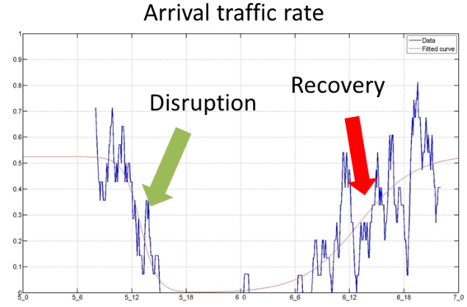
Figure 1: Arrival rate disruption followed by recovery (Case: Xaver) [4]

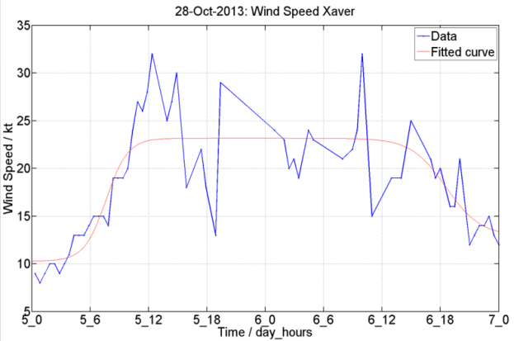
Figure 2: Time series of wind speed (Case: Xaver) [4]

2. Static Modeling
Modeling of both arrival rate and wind speed will be presented. We will have same model structure for both of them since their graphs have similar shape to each other, which is a series of increase and decrease (Figure 1, Figure 2). In order to describe this feature, the author suggests a model with several logistic functions.
$$F\left(t\right)=\sum_{i}{\left\{\frac{ΔF_{i}}{1+exp\left(-\frac{t-μ_{i}}{τ_{i}}\right)}+ε_{i}\right\}}+\sum_{j}{\left\{\frac{ΔF_{j}}{1+exp\left(\frac{t-μ_{j}}{τ_{j}}\right)}+ε_{j}\right\}}$$ | (1)
In this model, $ΔF$, $μ$, $τ$ and $ε$ are model parameters which respectively means difference of two equilibrium states, a time-shift parameter, time constant and stochastic noise. The first term with subscript $i$ corresponds to recovery (increase) and the second term with $j$ corresponds to disruption (decrease). We can model the behavior of both traffic and wind so that $F(t)$ can be both arrival rate $f(t)$ and wind speed $v(t)$. The results of parameter fitting without noise ($ε=0$) to empirical data of “Xaver” case are shown in the Figure 1 and Figure 2. The blue line shows the empirical data and the red line shows the fitted curve. The time scales of these two graphs are set to be same so that we can see the static model (1) can describe mean behavior of both arrival rate and wind speed. If we assume the noise has a normal distribution, noise calculation is also possible.
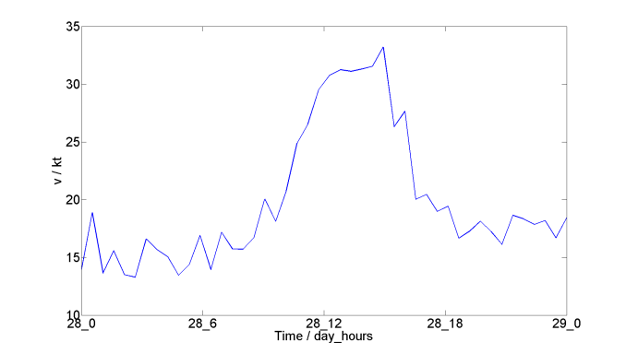
Figure 3: Static wind speed model with noise $ε$

This static analysis is worth conducting to see the whole picture of the empirical data. Also, the results here will help us construct dynamic model in the following section.
3. Dynamic Modeling
In the previous section, we constructed the static model. However static modeling is possible only when we know the whole picture of the behavior of traffic or wind. We need dynamic model, which has time evolution, to analyze ongoing traffic disturbance caused by wind. The dynamic model with time delay $T$ will be constructed based on Verhulst equation, the solution of which is logistic function.
 | $${τ\dot{f}}_{t+T}+f_{t+T}=G_{t}\frac{{\dot{v}}_{t}}{{\dot{v}}_{0}}\frac{v_{th}-v_{t}}{v_{th}}f_{t}(1-f_{t})$$ | (2)
In this equation, $f$ means normalized arrival rate while $v_{t}$ and ${\dot{v}}_{t}$ are wind speed and acceleration respectively. These wind factors plays a role so that arrival rate $f$ starts being disrupted if wind speed $v_{t}$ exceeds its threshold $v_{th}$. On the other hand, $G$ corresponds to management action and it is formalized as:
 | $${\dot{G}}_{t}=\frac{1}{τ_{f}}\left\{\left(f_{b}-f_{t}\right)+η\left(G_{b}-G_{t}\right)\right\}$$ | (3)
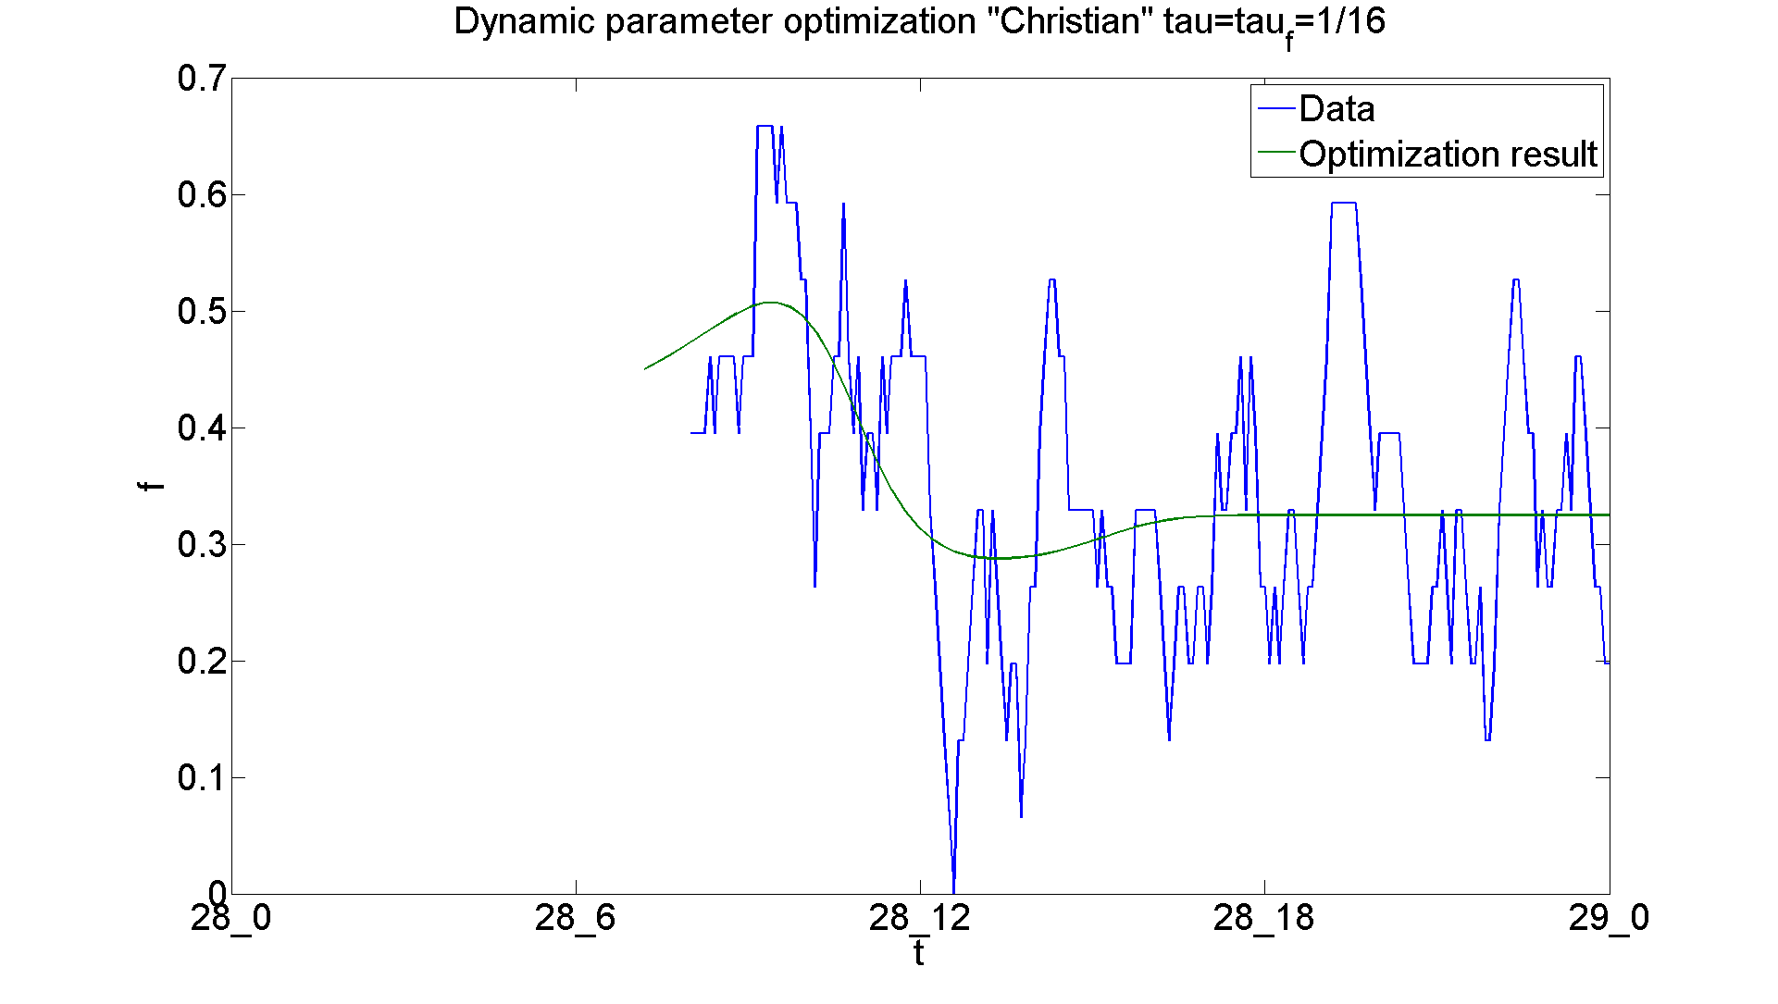
Here, $τ_{f}$ and $η$ are model parameters. $f_{b}$ and $G_{b}$, which should be set near the middle of the range of $f_{t}$ and $G_{t}$ respectively, are also model parameters called “bias parameters” which play a roll of preventing $G_{t}$ from getting far away from the desired values of both $f_{t}$ and $G_{t}$. These two coupled equations are proposed as a dynamic resilience model for our case. The result of parameter value optimization without time delay terms using empirical traffic data are shown in Figure 4. With the optimized parameter values, the dynamic model can explain the mean-value behavior of the empirical data. Note that (1) and its time derivative are used as $v_{t}$ and ${\dot{v}}_{t}$ respectively and wind noise $ε$ is not included. How the behavior changes when wind noise (Figure 3) is added to $v_{t}$ (but not ${\dot{v}}_{t}$) is shown in the Figure 5. The wind noise effect seems rather disruptive however it doesn’t bring arrival rate oscillation. The possible argument for this noise absorption is that $τ$ plays a role of low pass filter and arrival rate $f_{t}$ cannot follow $v_{t}$ noise much faster than the time period limited by $τ$.
Figure 4: Traffic data and parameter optimization result (Case: Christian) [4]

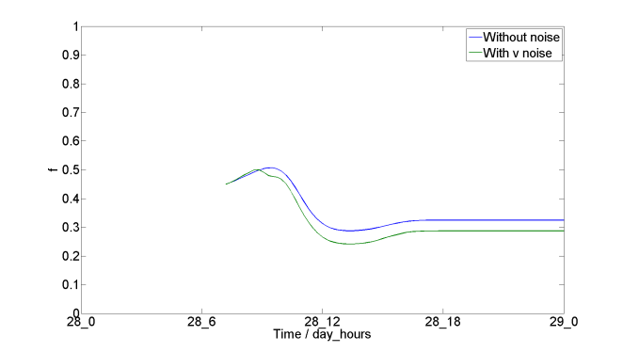
Figure 5: $f-t$ plot with and without $v_{t}$ noise

4. Quasi-potential analysis
When we consider the fact that $f$ has normal and disrupted stationary state, we can understand that traffic disruption means wind factor $w\left(v,\dot{v}\right)=(\dot{v}/{\dot{v}}_{0})\{(v_{th}-v)/v_{th}\}$ makes $f$ shift from a normal stationary state to a disrupted stationary and traffic recovery means management action $G$ has the opposite influence on traffic. With certain deformations of (2) and (3), we can find analogy to conventional Newtonian dynamics and can define “quasi-potential” with which we can discuss phase transition of $f$ [4]. The form of quasi-potential in our case is:
$$u=-\frac{w}{τ+T}\left[\frac{1}{2}\left(c-\frac{η}{τ_{f}}G\right)f^{2}-\frac{1}{3}\left\{c+\frac{1}{τ_{f}}\left(1-ηG\right)\right\}f^{3}+\frac{1}{4}\frac{1}{τ_{f}}f^{4}\right]$$ | (4)
The potential $u$ has three stationary states: $f^{**}=0, 1, f_{b}+ηΔG$. This form has a fourth order so that we can depict two-dimensional potential curve $u(f)$ when the values of external factors $G$ and $w$ are given (Figure 6). Similarly, we can draw three-dimensional potential surface $u(f,w)$ when the value of $G$ is given (Figure 7). The curve/surface can be regarded as a slope on which a ball is moving under the gravity. $w$ and $G$ change the shape of the slope so that the ball representation of $f$ changes its position. The detailed change in shape dependent on $G$ is shown in [1].
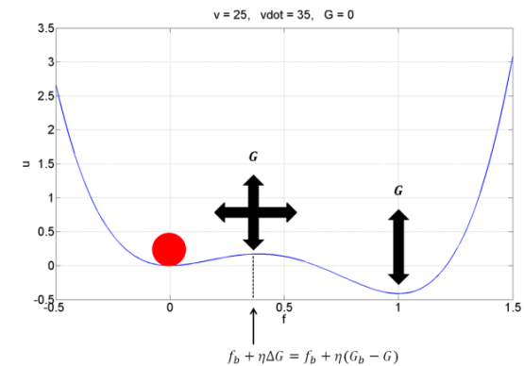
Figure 6: Quasi-potential curve and ball representation

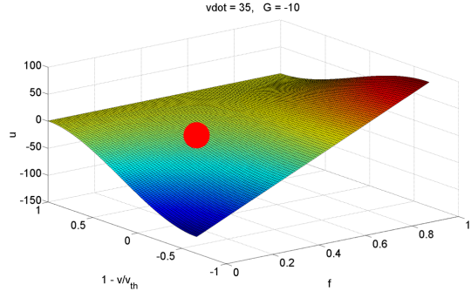
Figure 7: Quasi-potential surface and ball representation

5. Practical operation
Our work is so far rather theoretical. Since our long-term goal is implementation of our models as a disruption prediction system or apply them to optimization problem of management action, we need to consider how real operations are taken. This section contains criticism from a former air traffic controller.
He pointed out that there must be some more reasons other than wind speed increase to disrupt arrival traffic. According to his opinion, the average wind speeds of the two storms are not high enough to disrupt arrival traffic and finally close the runways. Our model can surely describe one aspect of possible reasons of the traffic disruption but it is not the whole picture. Other possible reasons for disrupting air traffic may be wind gust, turbulence, wind direction change, runway icing, accident at the airport, ILS location problem, capacity problem of the airport and so on. Among these possibilities, wind direction plays a crucial role for decision making about runway usage. Since an approaching aircraft can be greatly affected by side wind and tailwind, air traffic controllers always take care of wind direction and wind speed as one set. He suggested us to introduce wind direction factor to our model.
One idea to introduce wind direction is presented in the Figure 8. It shows two runways seen from above. Basically, each runway $i,j,k,l$ has its own dynamic model (2) and (3) to describe its own traffic behavior. Then the space around the runways is divided into four parts. Which runway is used is determined by wind direction. If wind blows in the direction which a red arrow shows, the runway $i$ is used. This is a very simple rule but can describe a management policy which avoids tail wind.
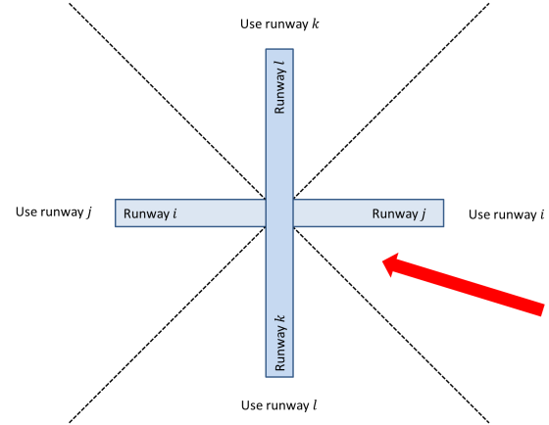
Figure 8: Possible introduction of wind direction

6. Conclusion
The author proposed basis of several kinds of modeling and analysis. Continuous researches at DLR are ongoing to develop them further. The expected applications are prediction of traffic disruption, optimization for obtaining desired management action, collaboration with other DLR research about runway utilization and so on.
Acknowledgement
The authors greatly appreciate Mr. Michael Finke, who used to be an air traffic controller for his discussion about practical operations.
References
[1] | Norbert Fürstenau, Shumpei Kamo, Monika Mittendorf, „Dynamical Performance Model for Quantifying and Simulating Air-Traffic Disruption and Recovery under Strong Disturbance – Investigations in ATM Resilience,“ 2015.
[2] | Royce Francis, Behauli Bekera, „A metric and frameworks for resilience analysis of engineeredand infrastructure systems,“ Reliability Engineering and System Safety, Bd. 121, pp. 90-103, July 2014.
[3] | Guillaume Deffuant, Nigel Gilbert, Viability and Resilience of Complex Systems, Springer, 2011.
[4] | H. Haken, Synergetics, Springer, 1983.

