The CellFlux storage concept for cost reduction in parabolic trough solar thermal power plants
Christian Odenthal, Wolf-Dieter Steinmann, Markus Eck und Doerte Laing
christian.odenthal@dlr.de
Although facility scale thermal energy storage of sensible heat in the range of 200-600°C has achieved a high maturity, state-of-the-art approaches are still not very cost effective. An innovative storage concept is thus proposed here that avoids the two major cost-driving factors of the concrete storage and 2-tank molten salt systems. First, the storage volume is comprised of low-cost sensible storage material such as concrete, natural stone or clinker bricks. These materials are several times cheaper than eutectic salt mixtures used in the 2-tank-storage system. Secondly, the system uses an intermediate air cycle, allowing for direct contact with the storage material. The necessary heat exchanger for transferring the heat from the primary oil loop to the intermediate air cycle consists of significantly less steel compared to the tube register inside the concrete storage. All components are kept in close proximity inside an enclosed loop, thus avoiding long flow lengths and keeping parasitic losses within a reasonable range. A schematic illustration is shown in Figure 1.
Preliminary investigations have shown that the overall performance and profitability of the storage system are closely linked to the thermal efficiency and pressure drop of the heat exchanger, the effectiveness of the storage, as well as the operation strategy. To demonstrate the feasibility of the storage concept and to investigate its performance characteristic under realistic conditions, a pilot scale test facility has been set up. In parallel, dynamic models of the storage system and a SEGS-like solar thermal power plant have been implemented in a Matlab/Simulink environment to analyze its performance theoretically. Experimental data is also used for model validation.
The conference presentation gives a detailed overview of potential configurations and their dynamic behavior. Furthermore, first experimental results of the demonstration facility are presented.
Figure 1 - Basic concept of CellFlux storage module during charging mode
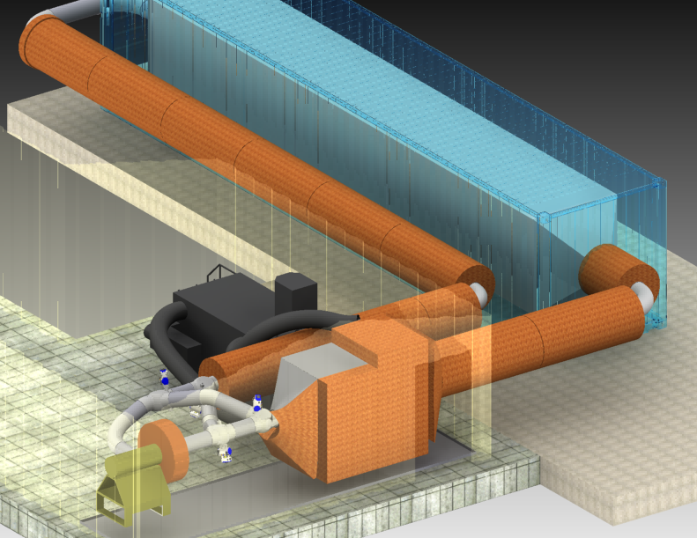
Figure 2 - Model of planned pilot test facility

