Impurity-based infrared emitters in silicon

S. G. Pavlov
German Aerospace Genter (DLR), Institute of Planetary Research, Rutherfordstr. 2, 12489 Berlin, Germany
sergeij.pavlov@dlr.de

In the past few years significant progress has been made towards silicon-based lasers. Because of indirect band structure, optical band-gap transitions are not allowed in bulk silicon. Numerous approaches were proposed to overcome this difficulty in the near infrared wavelength range, such as silicon nanocrystals, Si/SiO₂ and Si/SiGe superlattices, porous silicon, erbium-doped silicon and silicon light-emitting diodes. Recently, an infrared 1.67 µm silicon laser based on stimulated Raman scattering has been reported [1].
The first silicon laser was realized in terahertz range by infrared optical excitation of group-V donor centres embedded in a silicon host lattice [2] (Fig. 1). This laser uses direct optical transitions between atom-like states of the shallow donors attached to the bottom of the silicon conduction band. Terahertz Stokes silicon laser, recently announced [3], employs the combined light scattering on impurity centres, whose excited 1s(E) and ground 1s(A₁) states are resonantly coupled by an intervalley transverse acoustic phonon (Fig. 2).

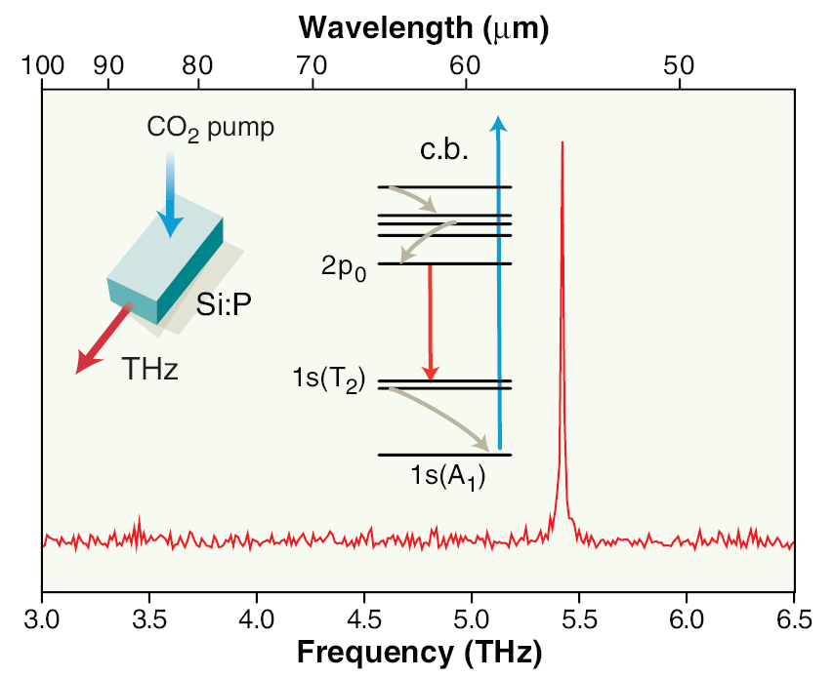 | 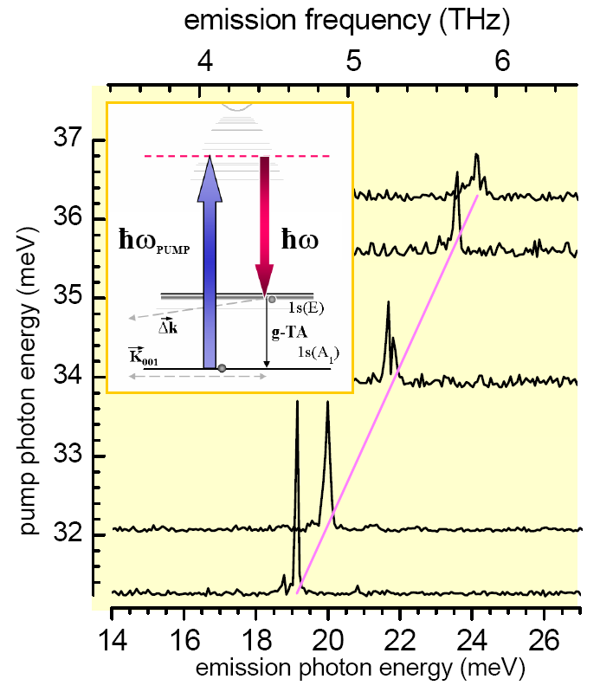
Fig. 1: Intracentre phosphorus-doped silicon laser.
Si:P laser utilizes optical transition between hydrogen-like 2p₀ and 1s(T₂) donor states (arrow down), so that energy of the emitted photon is equal to the energy gap between the donor states:
ħω = E_{2P0} – E_{1ST2} ≈ 5.35 THz.  Left inset: Optical pumping of Si:P by a CO₂ laser leads to terahertz laser emission.  Middle inset: In Si:P, pump photons excite carriers from the 1s(A₁) ground state to the conduction band (c.b.) (arrow up). The carriers fall to the 2p₀ state by nonoptical transitions (diagonal arrows down) and accumulate there, creating an inversed population of the 2p₀ phosphor state. | Fig. 2: Stokes antimony-doped silicon laser.  Left inset: Optical pumping of Si:P by tunable infra-red free electron laser leads to THz laser emission due to resonant Brillouin-type scattering on donor centres. Donor electron is excited in the virtual state (dash line) following by emission of a 2.9-THz acoustic g-phonon accompanied by an electron relaxation between the lower laser 1s(E) state and the ground 1s(A₁) state, so that the energy of the emitted photon:  ħω = ħω_{PUMP} – hν_{PHONON} ≈ ħω_{PUMP} – 2.9 THz.
______________________________________
[1] H. Rong et al., “An all-silicon Raman laser”, Nature 433, 292 (2005).
[2] S. G. Pavlov, R. Kh. Zhukavin, E. E. Orlova, V. N. Shastin, A. V. Kirsanov, H.-W. Hübers, K. Auen, and H. Riemann, ”Stimulated emission from donor transitions in silicon”, Phys. Rev. Lett. 22, 5220 (2000).
[3] S. G. Pavlov, H.-W. Hübers, J. N: Hovenier, T. O. Klaassen, D. A. Carder, P. J. Phillips, B. Redlich, H. Riemann, R. Kh. Zhukavin, and V. N. Shastin, “Stimulated Terahertz Stokes Emission of Silicon Crystals Doped with Antimony Donors”, Phys. Rev. Lett. 96, 037404 (2006).

