INFRASTRUCTURE ASSESSMENT OF URBAN ROAD NETWORKS
P. Mieth, S. Lorkowski, R.-P. Schäfer
Institute of Transport Research
German Aerospace Centre
Rutherfordstrasse 2
12489 Berlin
Germany
e-mail: Peter.Mieth@dlr.de

This paper describes a methodology to evaluate and compare vehicular traffic on complex urban road networks. It is focused on an integral assessment of whole urban nets trying to find quality criteria to be used by urban planers and infrastructure designers. Therefore, we aim to derive few simple but meaningful indicators usable in a generalized way. Such a quantity is the fraction of the total road net which is characterised by a certain velocity class. This allows the identification of the road length in the net suffering from heavy congestion, e.g. during peak traffic hours. Another concise method is the calculation of isochrones to mark the accessibility of urban and suburban areas from important economic or public centres in the city. All these methods rely on area-wide traffic monitoring data currently not available from conventional data sources. Therefore, probe vehicle data from a taxi fleet were used to establish an appropriate data base.

Introduction
Urban planers and traffic engineers still do not have appropriate tools to evaluate an urban road net as a whole. They normally focus on few important corridors and major junctions in the city measuring the traffic throughput across arterials and travel times along selected routes. Also, traffic engineers often optimize traffic light signals at major junctions [De Schutter 1996] just with respect to one route completely neglecting all the others. However, urban road networks are complex structures with a high degree of interdependencies between different edges of the net. For example, changing the capacity at one part of the net might significantly affect other, even fairly remote, areas. To evaluate infrastructure measures or to compare the road net quality of different cities or districts, a number of integral evaluation methods are desirable. The methods described below are based on a comprehensive long-term traffic monitoring for the area to investigate. Common traffic measurements like induction loops or video observations are not capable to supply sufficient data sets for this task. Therefore, we utilise positioning data of taxis as traffic data provider.

The Data
The evaluation methods are based on averaged travel time matrices for all streets of the region of interest or at least for all major roads. These matrices were calculated by using taxis as probe vehicles. The taxis move within the normal flow of traffic, estimate their current positions using GPS for fleet disposition purposes. They transmit the data to a head office regularly, in average once per minute. We just constantly collect these Probe Vehicle Data (PVD) sent by the vehicles, pre-filtering non-plausible data. A sufficient high detection frequency allows a good identification of coherent taxi trajectories along the road network. Applying a map matching and routing algorithm to assign the taxi position data to segments given by a digital road map (NAVTEQ road maps have been used for this study) leads to road segment velocities. The data are processed to hourly averages separated by each week day. In contrast to stationary traffic sensors we cannot derive information about vehicle fluxes. Nevertheless, we can estimate average travel times on each road segment which was cruised by a taxi during the period of interest. Exploiting a considerable large fleet this allows the computation of time-dependent velocities for a representative part of the road network [Kühne 2003]. Meanwhile, several million probe vehicle data have been collected during the last three years for a couple of large European cities, e.g. Berlin, Vienna, Nuremberg, Munich, Stuttgart and Regensburg. In this paper we present results for the city of Berlin.

Local Network Analysis
First of all, the data allow a detailed analysis of individual parts of the net where data penetration is adequate. For example, Figure 1 shows the average speed on road segments of a major traffic circle in Berlin. During the morning rush hour (left panel) a considerable low velocity is indicated on the southern road Hofjägerallee in driving direction north. At the evening at 8 p.m. this congestion disappeared on this part of the road (right panel).

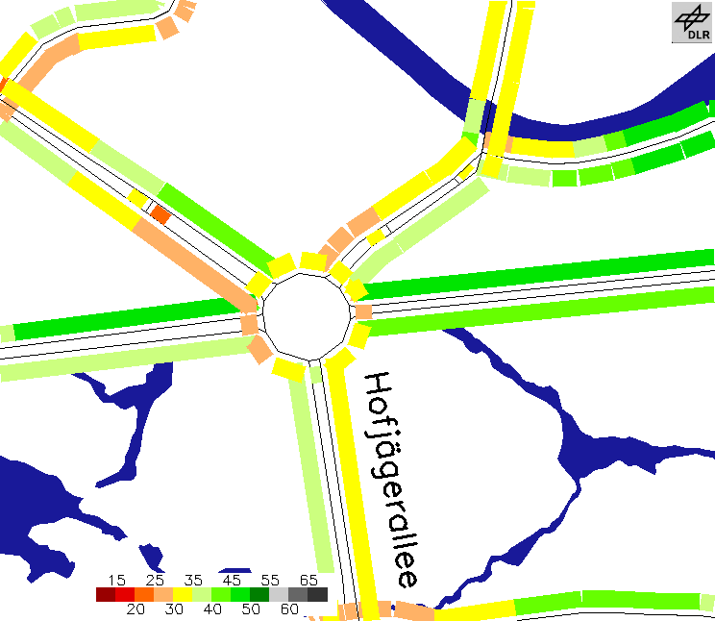
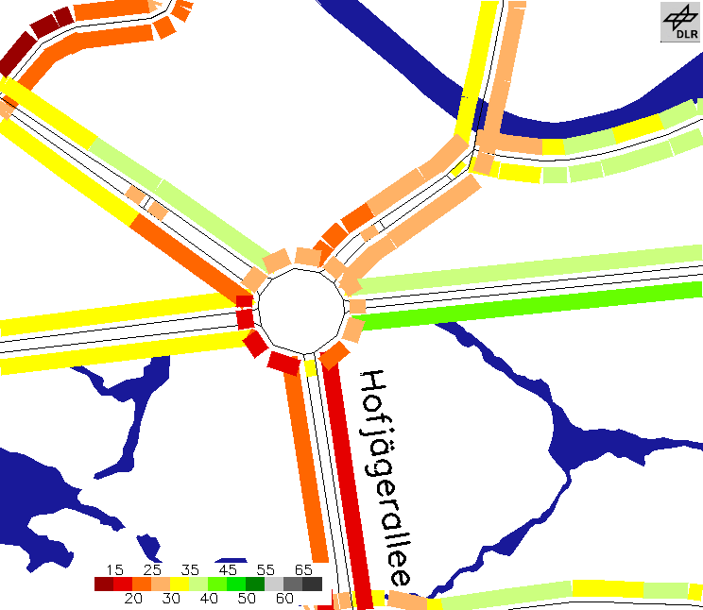

.

Figure 1: Speeds [km/h] on network segments on Monday for a major junction in Berlin at 8 a.m. (left) and 8 p.m. (right)

The daily courses for all week days are given in Figure 2. In contrast to data collected by induction loops, the velocities of the daily course are not point values but represent the average velocities for all lanes of a tiny street segment in one direction, on average a 70 m long piece of road. In Figure 2 (left panel), a very pronounced rush hour velocity breakdown in the morning and during the evening is visible on working days. On Friday, the evening rush hour starts even earlier and ends also earlier. On Sunday the breakdowns vanish. In the other driving direction of the same road (right panel), only a strong morning rush hour speed collapse is visible on working days. The assessment quantities described below are based on this time dependent small scale velocity data.
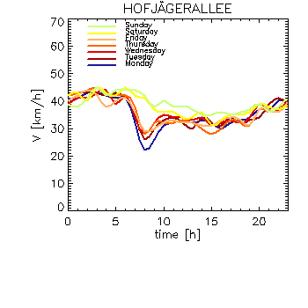
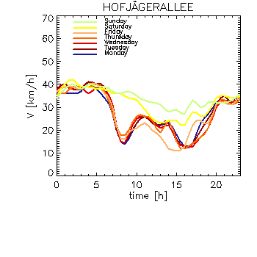
Figure 2: Daily course of velocity for all week days for road segment Hofjägerallee in driving direction north (left) and driving direction south (right)

Speed Distribution of Road Networks
Based on this time dependent speed information of most important links of the road network some elementary statistical investigations give valuable measures of the overall behaviour of the road net. The calculated fraction of the total road net length in a given speed category derived by accumulated PVD-based segment velocities gives a descriptive picture of the typical time-dependent integral net characteristic. At the moment, PVD penetration of tiny roads is still not sufficient to allow an assessment of minor roads. Additionally, because it is often undesired that these small roads take much of the through traffic in residential areas, they show a rather low speed limit. Therefore such streets are not very important for the overall net quality and have been excluded from the analysis.
As an example, the distribution of road kilometres within velocity classes for a typical working day at 8 a.m. (Monday to Thursday average) in Berlin is given in Figure 3 (left). For comparison, the right panel illustrates the situation on Sunday at the same time. This analysis takes only into account major roads (including the city motorway with speed allowance of
80 km/h to 100 km/h). The highest speed class includes all speed occurrences above 80 km/h.

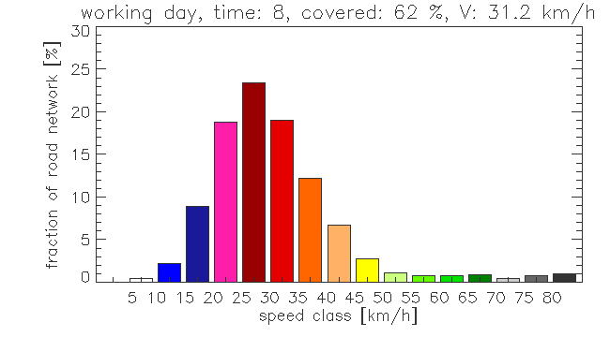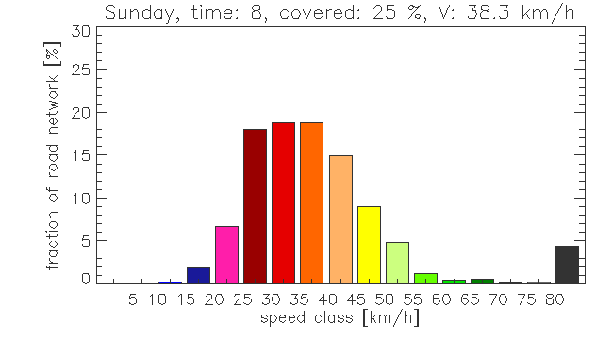

Figure 3: Distribution of the road net in speed categories, on working days 8 a.m. (left) and on Sunday 8 a.m. (right)

On normal working days at 8 p.m. the speed on nearly 12% of the total main road net falls below 20 km/h. Most of this length can be considered as congested or even suffering from traffic jams. Obviously, a small portion can be attributed to low speed mode mainly due to intersections, the street course and vehicle turns. On Sunday morning, there is nearly no congestion (right panel). The average speed is about 38 km/h whereas this quantity is around 31 km/h on working days. The most likely speed on working days is between 25 and 30 km/h and on Sunday between 35 and 40 km/h. There is a definite shift towards lower speeds on working days, and even on the city motorway the speed drops down considerably. To account for time-dependent driving behaviour of the probe vehicles (the distribution of driven kilometres between different road types differ sometimes considerably), the estimated quantities of a certain road type are weighted by the fraction of travelled kilometres on this particular street type and its total occurrence in the region of interest.
This method can be applied in an hourly resolution. Additionally, running the analysis for an isolated area allows finding out infrastructure deficiencies in particular regions. Moreover, year to year tendencies can be evaluated to identify significant changes of the quality of the road net.

Accessibility Analysis
When companies choose the location for a new factory, office or store its accessibility by individual traffic is one major criterion. That applies to private persons in a similar way when they look for a new home. Obviously, the accessibility of districts of cities is highly important for the design and dimensioning of new infrastructure, in traffic planning as well as in development planning [Spiekermann 1994, Halden 2000, Schürmann 2000].
Using PVD described above the accessibility of each part of the road net can be estimated with high accuracy according to day of week and time of day. Therefore the travel times from a selected site to each knot in the road net are calculated. A single source shortest path algorithm like Dijkstras algorithm [Dijkstra 1959] can be used for that. It has to be carried out only once per scenario, the computational effort is low. The travel times along the roads are estimated based on PVD. As an example, Figure 4 shows the accessibility of the Brandenburg Gate, Berlin, for a typical Monday, 8 p.m.

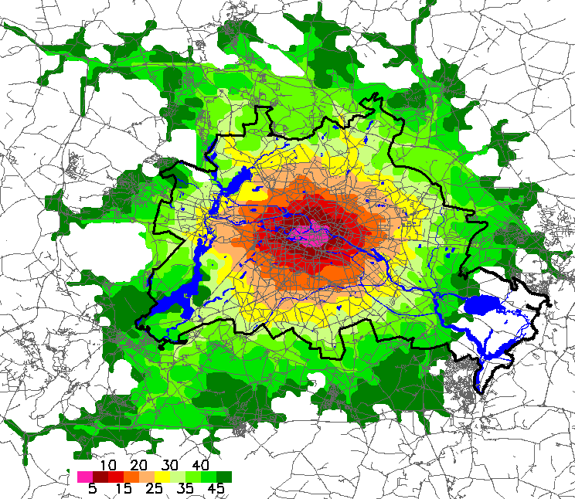
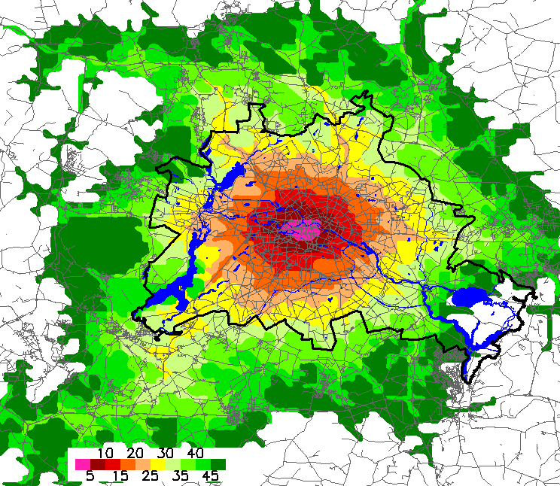

Figure 4: Isochrones of travel time in minutes from (left) and to (right) the Brandenburg Gate, Berlin, on a typical Monday, 8 p.m.

Figure 4 shows that in the morning hours the average travel times towards the city center (right panel) are significant longer then in opposite direction (left panel). Furthermore the noncircular shape of the isochrones indicates asymmetries in the quality of road infrastructure, especially between the southwest and southeast part of Berlin. This may be a result of and/or a cause for the different population densities in these areas.
For many companies it is important that their location is accessible by as many as possible “persons of interest” (e.g. customers, suppliers, employees) in an as short as possible time. If the local distribution of these “persons of interest” is known, their average travel times to each potential location can be calculated using the method mentioned above. Utilising this technique the accessibility of each location by road can be evaluated from a company’s point of view. Because of the profound knowledge of travel times from PVD this method is more accurate then using conventional approaches. Attention should be paid to the amount of additional traffic induced by the company itself, which may reduce the estimated accessibility of the location.

Conclusions
The presented methods for an integral urban road net assessment can be recommended for regions having a reasonable complete knowledge of time-dependent road speeds. These data might be obtainable with a justifiable effort by probe vehicles only. On the basis of these data, statistical evaluation, comparison and trend analysis of the vehicular quality of urban networks are feasible with a high degree of reliability. Nevertheless, some misinterpretations may occur caused by data collected from special fleet probe vehicles, e.g. taxis. Future work will be directed to the analysis of long term trends and to achieve higher data penetration.
Finally, it needs to be mentioned that the proposed road infrastructure quality measures are only focused on the technical issues of vehicular traffic. Obviously, more comprehensive investigations considering environmental, safety and social aspects as well as multimodal transport have to be included for planning and evaluation of urban mobility.

References
Dijkstra, E. W., 1959, A Note on two Problems in Connections with Graphs, Numer. Math., 1, pp. 269-271.

Halden, D., McGuigan, D., Nisbet, A., McKinnon, A., 2000, Accessibility: Review of Measuring Techniques and their Application, Derek Halden Consultancy, Scottish Executive Central Research Unit.

Kühne, R., Schäfer, R.-P., Mikat, J., Thiessenhusen, K.-U., Böttger, U., Lorkowski, S., 2003, New Approaches for Traffic Management in Metropolitan Areas, 10th IFAC (International Federation of Automatic Control) Symposium on Control in Transportation Systems, Tokyo, Japan.

Schürmann, C., Spiekermann, K., Wegener, M., 2000, Erreichbarkeit und Raumentwicklung, In: Deiters, J., Gräf, P., Löffler, G. (Ed.), Nationalatlas Bundesrepublik Deutschland, Band 9 Verkehr und Kommunikation, Heidelberg, Spektrum Akademischer Verlag, pp. 124-127.

De Schutter, B., De Moor, B., 1998, Optimal traffic light control for a single intersection, European Journal of Control, vol. 4, no. 3, pp. 260-276.

Spiekerman, K., Wegener, M., 1994, The Shrinking Continent. New Time Space Maps of Europe, Enviroment and Planning B: Planning and Design 21, pp. 653-673.

