Name: Dr. Christoph Lass
Institute: German Aerospace Center, Institute of Communications and Navigation
Address: Kalkhorstweg 53, 17235 Neustrelitz, Germany
Phone: +49 3981 480-189
E-Mail address: christoph.lass@dlr.de
Snapshot Positioning in Multi-Antenna Systems for Inland Water Applications

Table of Contents
Introduction 3
1. Methodology 4
1.1. Single-Antenna approach 4
1.2. Multi-Antenna Approach 4
1.3. Weighting Schemes 7
2. Measurement Campaigns 8
2.1. Baltic Sea 8
2.2. Moselle River 9
3. Results 12
3.1. Baltic sea 12
3.2. Moselle river 13
4. Summary & Outlook 19
References 20

Introduction
The Global Navigation Satellite Systems (GNSS) can be considered as the cornerstone and the main information source for Positioning, Navigation and Timing (PNT) data in maritime and inland water navigation systems. It is rather well-known that the classical code-based positioning using an iterated least squares (LS) method lacks robustness. Even a single measurement outlier due to space weather events, multipath, non-line-of-sight (NLOS) or jamming can introduce a gross error in the final position solution. Although several approaches, such as classical Receiver Autonomous Integrity Monitoring (RAIM) techniques, have been designed to perform fault detection and exclusion, the methods are often based on a single fault assumption and therefore could fail when there are multiple simultaneous outliers (Wang, 2007). Although modifications have been suggested to eliminate multiple failures sequentially (Kuusniemi, 2004), the schemes can still fail as the correlations in the test statistics often lead to identification and rejection of the wrong satellite.
The presented work provides an extension of GNSS snapshot positioning schemes for the setup with multiple independent GNSS antennas. The position, the receiver clock offsets as well as the attitude of the ship are calculated in a LS ansatz using all separated GNSS antennas in one equation system. This has the advantage that fewer observations per antenna and in total are needed with respect to snapshot positioning for all antennas separately. The remaining redundant observations could improve the robustness against multipath and NLOS effects. This is especially important for challenging scenarios, e.g. under bridges, where there is a lack of redundancy of the data such that problematic observations cannot be removed.
In many practical applications it is rather common to use GNSS weighting models (GNSS leveraging) within the solution calculation. An additional discussion is provided on the extension of the presented methods for leveraged measurements using carrier-to-noise density (C/N0) information provided by the GNSS receiver. The presented methods were tested on two real-world scenarios - one having open-sky conditions in the Baltic Sea as well as a measurement campaign in Koblenz on the Moselle River where the vessel passed multiple bridges.

Methodology

Single-Antenna approach
The classical method to determine the position based on GNSS is an iterative weighted least squares approach. The three position coordinates $x_{i}$ of antenna $i$ in the ECEF coordinate system and its receiver clock offset $δt_{i}$ are determined using the equations of the following form (here for satellite $j$):
 | $$C_{j}^{i}=\left\|x_{j}-x_{i}\right\|+c_{0}δt_{i}$$ | (1)
Note that $C_{j}^{i}$ is the corrected code measurement where errors due to the troposphere, ionosphere and the satellite clock offsets have already been considered. $\left\|⋅\right\|$ is the Euclidean norm and $c_{0}$ is the speed of light. At least four independent observations are required to calculate the unknowns $x_{i}$ and $δt_{i}$.
Expressing (1) as a weighted least squares problem yields
 | $$\min_{\left(x_{i}, δt_{i}\right) ∈ R^{3} × R}{\frac{1}{2}\sum_{j=1}^{n_{i}}{ω_{j}^{2}{\left(\left\|x_{j}-x_{i}\right\|+c_{0}δt_{i}-C_{j}^{i}\right)}^{2} }}$$ | (2)

with${ ω}_{j}$ being positive and $n_{i}$ being the number of observations for antenna $i$.
This minimisation problem can be solved using Taylor series expansion to linearise the problem and applying the iterative Gauss-Newton method. Before different weighting schemes are introduced, the multi-antenna approach will be described in detail.

Multi-Antenna Approach
The developed multi-antenna method is based on the extension of the classical Gauss-Newton iterative weighted LS approach (2) for a system with at least three separated GNSS antennas. For the following discussion the number of antennas is assumed to be exactly three due to the measurement equipment on the ships. It is easy to generalise the following method for cases with more antennas.
The estimated state consists of three position coordinates $x$ of a reference point, three clock offsets $δt_{i}$ of correspondingly three GNSS receivers and the quaternion $q$ with a unit norm constraint. This quaternion describes the attitude of the ship in the ECEF coordinate system. The reference point is usually chosen in the neighbourhood of the antennas, e.g. one of the antennas itself, the barycenter or the location of the IMU.
For antenna $i$ and satellite $j$ this yields the following equation:
 | $$C_{j}^{i}= \left\|x_{j}- \left(x+R\left(q\right)L_{i}\right)\right\|+ c_{0}δt_{i}$$ | (3)

Note that $R(q)$ is the rotation matrix from the body framework to the ECEF coordinate system implied by the attitude quaternion, and $L_{i} ∶= x_{i} – x$ is the known lever arm of the reference point $x$ to the position $x_{i}$ of antenna $i$ in the body framework. The other variables retain their meaning from (1).
At least nine code measurements are required to calculate the unknowns since $\left(x,δt, q\right)∈ R^{3}× R^{3}× R^{4}$ and due to the norm constraint of the quaternion. Note that the number of required observations can even be smaller for a receiver with multiple antennas where only one receiver clock offset has to be determined. This is an advantage over the single-antenna approach which requires at least four observations per antenna, and thereby twelve observations in total for three antennas.
To put (3) in a weighted least squares content, the function $f_{k}$ is defined as
 | $$f_{k}\left(x,δt,q\right) ∶= \left\|x_{j}- \left(x+R\left(q\right)L_{i}\right)\right\|+c_{0}δt_{i}-C_{j}^{i}$$ | (4)

which implies the weighted least squares problem
 | $$\min_{\begin{aligned}\left(x, δt,q\right) ∈ R^{3} × R^{3} × R^{4} \\ \left\|q\right\|=1\end{aligned}}{\frac{1}{2}\sum_{k=1}^{n}{ω_{k}^{2}f_{k}^{2}\left(x,δt,q\right) }}$$ | (5)

with $n ∶= n_{1} + n_{2} + n_{3}$ being the total number of observations for all three antennas.
Special care is taken in preserving the norm constraint of the attitude quaternion by using the exponential mapping function (Ude, 1998)
 | $$\exp{ : }R^{3}→ \left\{q∈R^{4} : \left\|q\right\|=1\right\} \\ \exp\left(w\right) ∶= \left\{\begin{matrix}{\left(\cos\left(\left\|w\right\|\right),\sin\left(\left\|w\right\|\right)\frac{w}{\left\|w\right\|}\right)}^{⊤} w≠0_{3} \\ {\left(1,0,0,0\right)}^{⊤} w=0_{3}\end{matrix}\right.$$ | (6)

instead of the quaternion$q$. This yields the following weighted least squares problem which is equivalent to (5):
 | $$\min_{\left(x,δt,w\right) ∈ R^{3} × R^{3} × R^{3}}{\frac{1}{2}\sum_{k=1}^{n}{ω_{k}^{2}f_{k}^{2}\left(x,δt,\exp\left(w\right)\right)}} \\ = \min_{\left(x,δt,w\right) ∈ R^{3} × R^{3} × R^{3}}{F\left(x,δt,\exp\left(w\right)\right)}$$ | (7)

Note that this formulation makes it easier to see why nine observations can suffice. The minimisation problem (7) is solved by linearising $f_{k}$ using Taylor series expansion and using the modified Gauss-Newton method where the additive updates in each iteration are damped by using $λ∈(0,1]$ with
$$F^{(l+1)}\left(λ\right) ∶= F\left(x^{\left(l\right)}+λΔx, {δt}^{\left(l\right)}+λΔδt,w^{\left(l\right)}+λΔw\right) \\ M ∶= \left\{λ∈ \left\{1,\frac{1}{2},\frac{1}{4},\frac{1}{8}\right\} :F^{\left(l+1\right)}\left(λ\right)<F^{\left(l+1\right)}\left(0\right)\right\} \\ λ= \left\{\begin{matrix} \frac{1}{8} M=∅ \\ \max{M} else\end{matrix}\right.$$
This is done to avoid convergence issues since the Gauss-Newton method is known to only converge locally, and it can make large updates which deviate from the root. Note that $w$ is actually not used between different iterations but a multiplicative quaternion update is done which is known to preserve the norm of unit quaternions.
$$\exp\left(w^{\left(l+1\right)}\right)=q^{\left(l+1\right)}=\exp\left(0_{3}\right) ⊗q^{\left(l+1\right)} \\ =\exp\left(δw\right)⊗q^{\left(l\right)}$$
In each iteration $δw$ is calculated and used to update the attitude quaternion. This multiplicative update has to be considered when determining the derivate of $f_{k}$ with respect to$δw$:
$$D_{δw}f_{k}\left(x,δt,\exp\left(δw\right)⊗q\right){\left.\right|}_{δw = 0_{3}} \\ =D_{q}f_{k}\left(x,δt, q\right)\left(\begin{matrix}-q_{2} & -q_{3} & -q_{4} \\ q_{1} & q_{4} & -q_{3} \\ {-q}_{4} & q_{1} & q_{2} \\ q_{3} & -q_{2} & q_{1}\end{matrix}\right)$$

Weighting Schemes
The following three weighting schemes are considered for the two measurement campaigns in the next chapter.

Elevation angle (EA)
It has been proven the possible errors of the observed pseudoranges increase with low elevation satellites (Wang, 1998). As the navigation message covers a longer distance through the ionosphere layer, it is deeply affected. Furthermore, the signals are more likely to get reflected compared to the signal coming from a satellite with a high elevation.
$$\frac{1}{ω_{k}^{2}}= \frac{1}{\sin^{2}\left(θ_{i}\right)}$$

Carrier-to-noise ratio (C/N0)
Carrier-to-noise ratio is a measure of signal strength and represents current signal power conditions.
$$\frac{1}{ω_{k}^{2}}= a+b⋅{10}^{-\frac{CN_{0}-c}{10}}$$
The parameters are chosen according to the environment and the user equipment. For both measurement campaigns, the parameters were found as $a = 0.60006$, $b = 50.6932$ and $c = 33.8385$ as a result of a regression problem (Ziebold, 2017).

Equal weights for all satellites (N)
Both schemes will also be compared to a simple scheme using no weighting at all.

Measurement Campaigns

Baltic Sea
A measurement campaign of 2015 (day of year (doy) 69-78) was chosen to test the performance of the multi-antenna approach under open sky conditions. The vessel used for this campaign was the MS Mecklenburg-Vorpommern from Stena Lines which is a rail ferry. Its daily plying route (see Figure 1 below) is between Rostock (Germany) and Trelleborg (Sweden) which is about 165 km long and takes six hours.
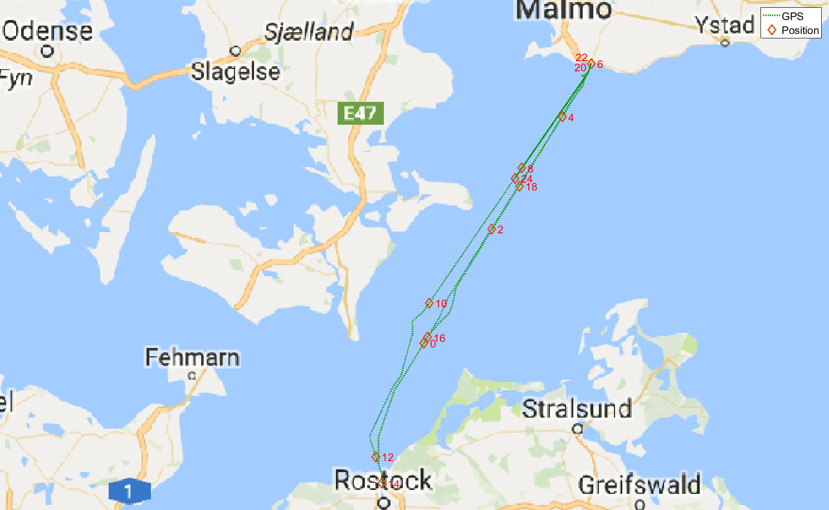
Figure 1: Route of MS Mecklenburg-Vorpommern with markers (red) for its position every two hours on doy 69, 2015
The ferry vessel was equipped with three dual frequency GNSS antennas, three receivers (Javad Delta) and two Inertial Measurement Units (IMU) as can been seen in the following figure. The distance between the GNSS antennas was 24.64, 31.42 and 24.67 meters.

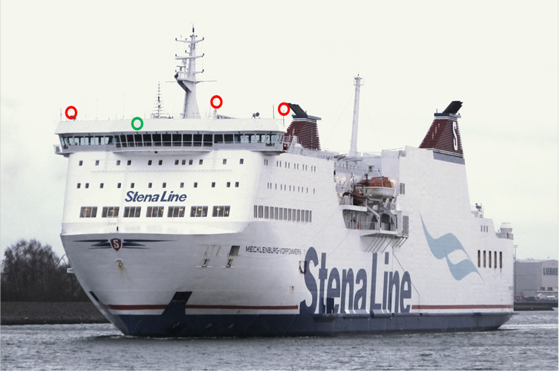
Figure 2: MS Mecklenburg-Vorpommern with three GNSS antennas (red circles) and two IMUs (green circle)
To get a reference trajectory the position of each antenna was calculated in post processing using the Precise Point Positioning (PPP) approach from the 1 Hz data of the entire doy 69. Also Real Time Kinematic (RTK) corrections data was applied from the Maritime Ground Based Augmentation System (MGBAS) in the port of Rostock. Analysis of the baseline length between the antennas showed a standard deviation of about 10 cm which is used as an estimate for the expected position accuracy. Using these reference antenna positions the absolute orientation was calculated using Horn’s method (Horn, 1987) to compare it to the attitude quaternion of the multi-antenna approach.

Moselle River
The performance of the developed methods under difficult environments has been evaluated using real observations from the measurement campaign conducted on 25th March 2014 (UTC 13:00 – 14:00) near Koblenz (Germany) on the Moselle river. The demonstrated area covers several challenging scenarios for inland water navigation as can be seen in the next figure.
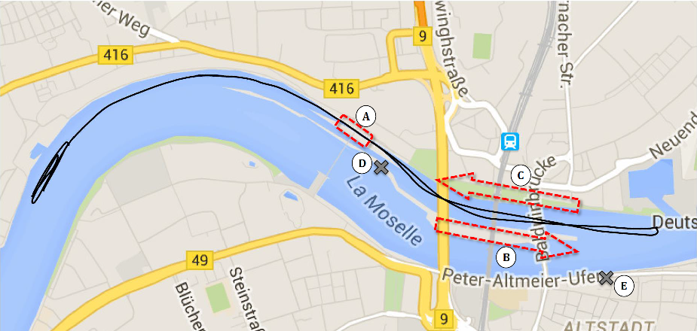
Figure 3: Measurement area on the river Moselle near Koblenz (Germany). Reference path (black line) and several challenging segments including the lock (A), and 3-bridge-segments (B) and (C). Geodetic total stations (D) and (E)
Sailing downstream, a lock bounds the measurement area three kilometers before the confluence with the Rhine River. After the lock, three bridges of different height and width span the river in a relatively short section ((B) and (C) in Figure 3) of only two kilometers. This is making reliable and continuous positioning using pure GNSS information rather challenging. The first bridge starting from the west is the tallest 4-lane car bridge called “Europabruecke” with a width of 40 meters and a clearance height of 13.9 meters. The next bridge is the railway bridge which is 25 meters wide with a low clearance of only 10.2 meters and oval clearance profile. The last one is the “Balduinbruecke” with a width of 10 meters and a height of 12.1 meters. Therefore, it is relatively small in comparison to the other two.
The vessel performed an 8-shaped trajectory (total duration 1 hour) with two passes under these bridges and the waterway lock in order to ensure that the GNSS signals are strongly affected by the shadowing from bridges and other obstacles.
The sensor system onboard the research vessel “MS Bingen” (see Figure 2) consisted of three geodetic GNSS antennas and Javad Delta receivers. The distance between the three GNSS antennas was 3.99 respectively 13.55 meters. The ionosphere propagation delay corrections have been applied using the classical Klobuchar model. The corresponding troposphere corrections are based on the Saastamoinen model in order for the results to be representative for user equipment without ground-based correction information (Borre, 2010). No elevation mask for GNSS satellites has been used as to ensure the best possible availability of the GNSS measurements.
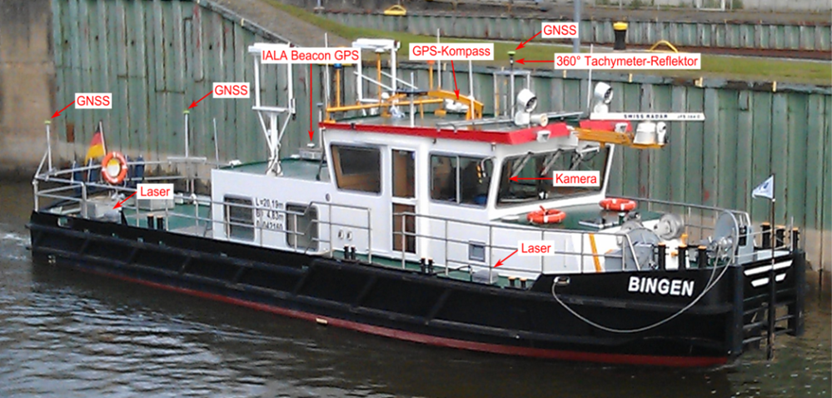
Figure 4: Research vessel “MS Bingen” used in the measurement campaign and the corresponding measurement equipment
In order to accurately track the position of the vessel without depending on GNSS information, two geodetic total stations (see (D) and (E) in Figure 3) have been placed on the shores of the river. As the total stations combine the use of angle and distance measurements in order to determine only the horizontal position, the vertical accuracy will not be addressed here. The coordinates of the tracked object are given relative to a known reference point and are determined using trigonometry and triangulation as long as a direct line of sight (LOS) in maintained between the two points. With the use of two total stations the availability of the reference trajectory is ensured even in the problematic areas where GNSS failed. After the reference 1 Hz position information is obtained, the post-processing and adjustment for the measurements ensure an accuracy of less than two centimeter for the presented evaluation path.

Results

Baltic sea

Horizontal positioning
The analysis starts with comparing the SPP solution of the antenna located midship with the multi-antenna approach using the location of the midship antenna as the unknown position.
Table 1: Comparison of horizontal positioning error (HPE) between single- and multi-antenna approach using the antenna located midship
Approach | Weighting scheme | HPE in [m]
 |  | Mean | RMS | 95 % | 99 % | 99.9 % | Max
Single  Multi | N  N | 1.52  1.20 | 2.05  1.38 | 2.91  2.26 | 4.76  2.93 | 18.87  7.12 | 37.08  19.91
Single  Multi | EA  EA | 1.68  1.33 | 2.19  1.56 | 3.41  2.63 | 5.38  3.70 | 16.45  6.38 | 45.88  26.23
Single  Multi | C/N0  C/N0 | 1.28  1.07 | 1.44  1.19 | 2.49  2.00 | 3.26  2.56 | 4.08  3.29 | 6.53  4.26

The results of the multi-antenna approach are clearly better for all weighting schemes which is to be expected as more observations are used to determine the position of the antenna. Additionally, the C/N0 weighting scheme provides the most accurate positioning, especially with regards to the largest HPE which is less than 10 meters for both single- and multi-antenna approach.
To make a fairer comparison between both approaches, all single-antenna positions are calculated and then used to determine the position of the barycenter. This is then compared to the multi-antenna approach using the barycenter as the unknown position.
Table 2: Comparison of HPE of barycenter obtained from single- and multi-antenna approach
Approach | Weighting scheme | HPE in [m]
 |  | Mean | RMS | 95 % | 99 % | 99.9 % | Max
Single  Multi | C/N0  C/N0 | 1.02  1.02 | 1.13  1.14 | 1.90  1.91 | 2.49  2.51 | 3.17  3.20 | 4.06  4.23

There is very little difference between these two results which shows that the multi-antenna approach is as good as using the barycenter of the SPP solution from the single-antenna approach and vice versa. Still, the multi-antenna approach has the advantage that it can even determine a position when there are less than four observations per antenna. Different satellite constellations were tested to confirm this and an accurate position (HPE < 2 m) could be calculated with three observations per antenna from four different satellites.

Attitude
Next, the orientation obtained from the attitude quaternion is checked against the PPP reference. Only the C/N0 weighting scheme is considered as it provided the smallest HPE.
Table 3: Accuracy of Euler angles obtained from attitude quaternion using C/N0 weighting scheme
Euler angle | Absolute difference in [°]
 | Mean | RMS | 95 % | 99 % | 99.9 % | Max
Roll  Pitch  Yaw | 2.29  3.38  1.08 | 2.94  4.28  1.38 | 5.83  8.44  2.75 | 8.18  11.33  3.80 | 12.61  15.32  5.50 | 26.17  24.60  10.42

The most interesting Euler angle yaw, as roll and pitch should be 0° under normal conditions, is also the one with the highest accuracy. Nonetheless, the maximum error is quite large for all Euler angles with regard to the mean absolute difference which could imply that the orientation calculated by the multi-antenna approach is more sensitive to faulty observations than the horizontal positioning. To further investigate this, a more difficult scenario is analysed in the following section.

Moselle river
For the multi-antenna approach described in section 1.2. antenna three, which is located midship (see Figure 4), has been chosen as the reference point. This is compared to the solution of the single-antenna approach with regard to antenna three. At first the quality of the positioning will be analysed whereas the calculation of the attitude is discussed afterwards.

Analysis of horizontal position
The horizontal positioning is compared between the different approaches and weights with respect to the ground truth calculated by the two total stations at the river Moselle. The following figure shows the results for the C/N0 weighting scheme.
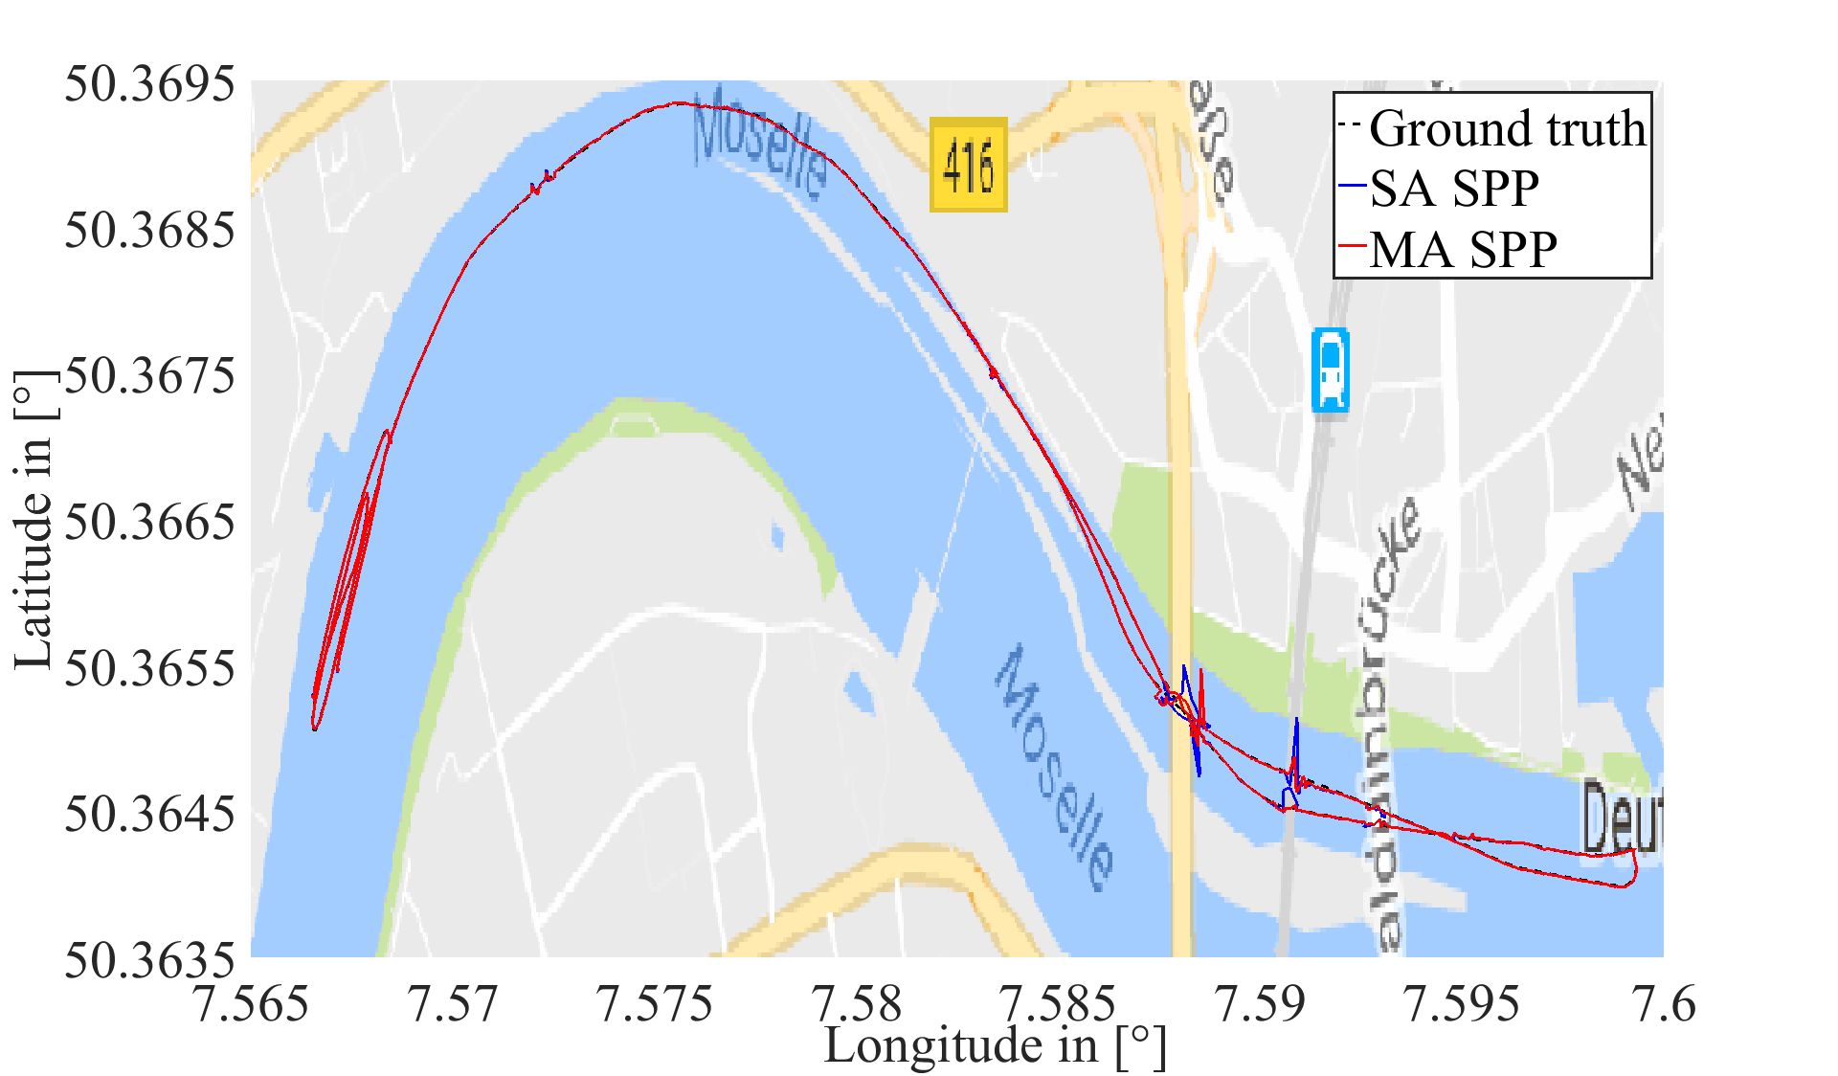
Figure 5: Horizontal position of single- and multi-antenna approach using the C/N0 weighting scheme
The overall horizontal position is tracked well, i.e. the mean HPE is less than three meters which is under the specifications of GPS L1. There is little difference between the two approaches in the mean as the ground truth can hardly be seen in this figure. The largest outliers occurred during the passing of the ‘Europabruecke’ and the railway bridge while the ‘Balduinbruecke’ seems to cause little errors. The same goes for the waterway lock which has little effect on the precision of the horizontal positioning. The passing of the bridges will be looked on in more detail later. In order to make a more thorough analysis the HPE will be presented in statistical values.
In the following table the HPE is given in the mean, the root mean square (RMS) and maximum as well as the values of the cumulative distribution function (CDF) for 95%, 99% and 99.9%.

Table 4: Comparison of HPE between single- and multi-antenna approach
Approach | Weighting scheme | HPE in [m]
 |  | Mean | RMS | 95 % | 99 % | 99.9 % | Max
Single  Multi | N  N | 2.89  2.75 | 4.53  4.17 | 5.30  4.88 | 20.90  16.10 | 41.48  41.74 | 50.70  47.61
Single  Multi | EA  EA | 1.70  1.73 | 4.15  3.32 | 2.69  3.11 | 16.16  16.40 | 58.09  37.14 | 91.79  45.49
Single  Multi | C/N0  C/N0 | 1.47  1.32 | 2.84  2.31 | 2.31  1.86 | 11.19  10.86 | 43.19  20.94 | 49.32  43.35

The accurate calculation of the horizontal position in the mean is confirmed by the table above for the schemes with regard to the observation of the satellites. Overall the C/N0 weighting scheme produces the best results for this measurement scenario which is especially noticeable in the larger (e.g. 95% or 99% CDF) errors where there is an improvements of several meters with regard to the other weighting options. Nonetheless, the difference in the mean to the elevation angle scheme is only in the decimeter regime. Note that the single-antenna approach causes a HPE of over 90 meters which does not happen with the multi-antenna approach. This shows that the additional redundancy in the number of observations helps with increasing the accuracy of the positioning. Also the multi-antenna approach has the best results for all weighting schemes with one of the few exceptions being the mean of the EA scheme.
A disadvantage of the multi-antenna scheme is the number of iterations needed to converge as the single-antenna approach only needed about five iterations in the mean to converge. This is in contrast to the multi-antenna scheme which needed about 20, 32 respectively 34 (N, EA and C/N0 weights) iterations in the mean to converge which is still small enough to ensure real-time computation capability.
A closer look is taken at the horizontal positioning during the passing of the three bridges where the largest HPE occurred.
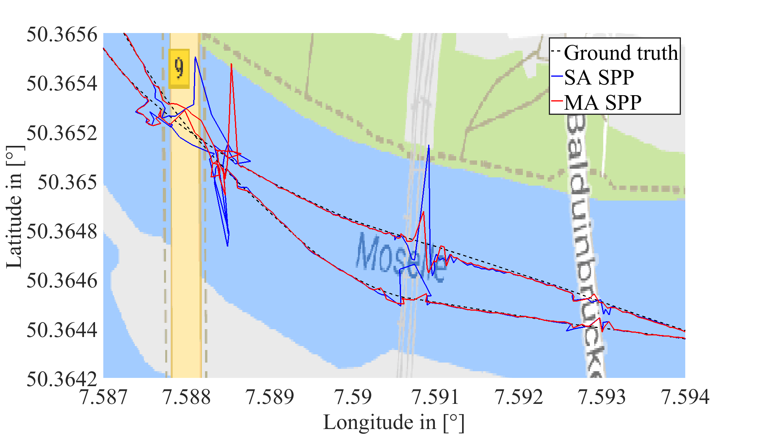
Figure 6: Horizontal position of single- and multi-antenna approach using the C/N0 weighting scheme during passing of bridges
The figure above confirms that the largest HPE occur during the passing of the ‘Europabruecke’ as well as the railway bridge while the ‘Balduinbruecke’ causes little deviations. What is interesting to see is that the multi-antenna approach in contrast to the single-antenna approach handles the railway bridge quite well. Also the multi-antenna results only have one large outlier with an HPE of over 40 meters at the ‘Europabruecke’ where as the single-antenna approach has two of them there.
Overall the multi-antenna approach provided a more accurate positioning in the mean as well as in the worst cases where the largest HPE occur.

Quality of attitude quaternion
In the last subsection the attitude quaternions computed by the multi-antenna approach are discussed. Only the results using the C/N0 weighting scheme are considered as they provided the most accurate positioning. Unfortunately, no reference compass data was available for this measurement campaign. Therefore, only a qualitative analysis can be done.
The next figure shows the Euler angles derived from the quaternion for the first six minutes. Note that during that period there were no high structures around the measurement area which could cause unwanted effects such as multipath of NLOS. The radius in the figure represents the time of the sample.
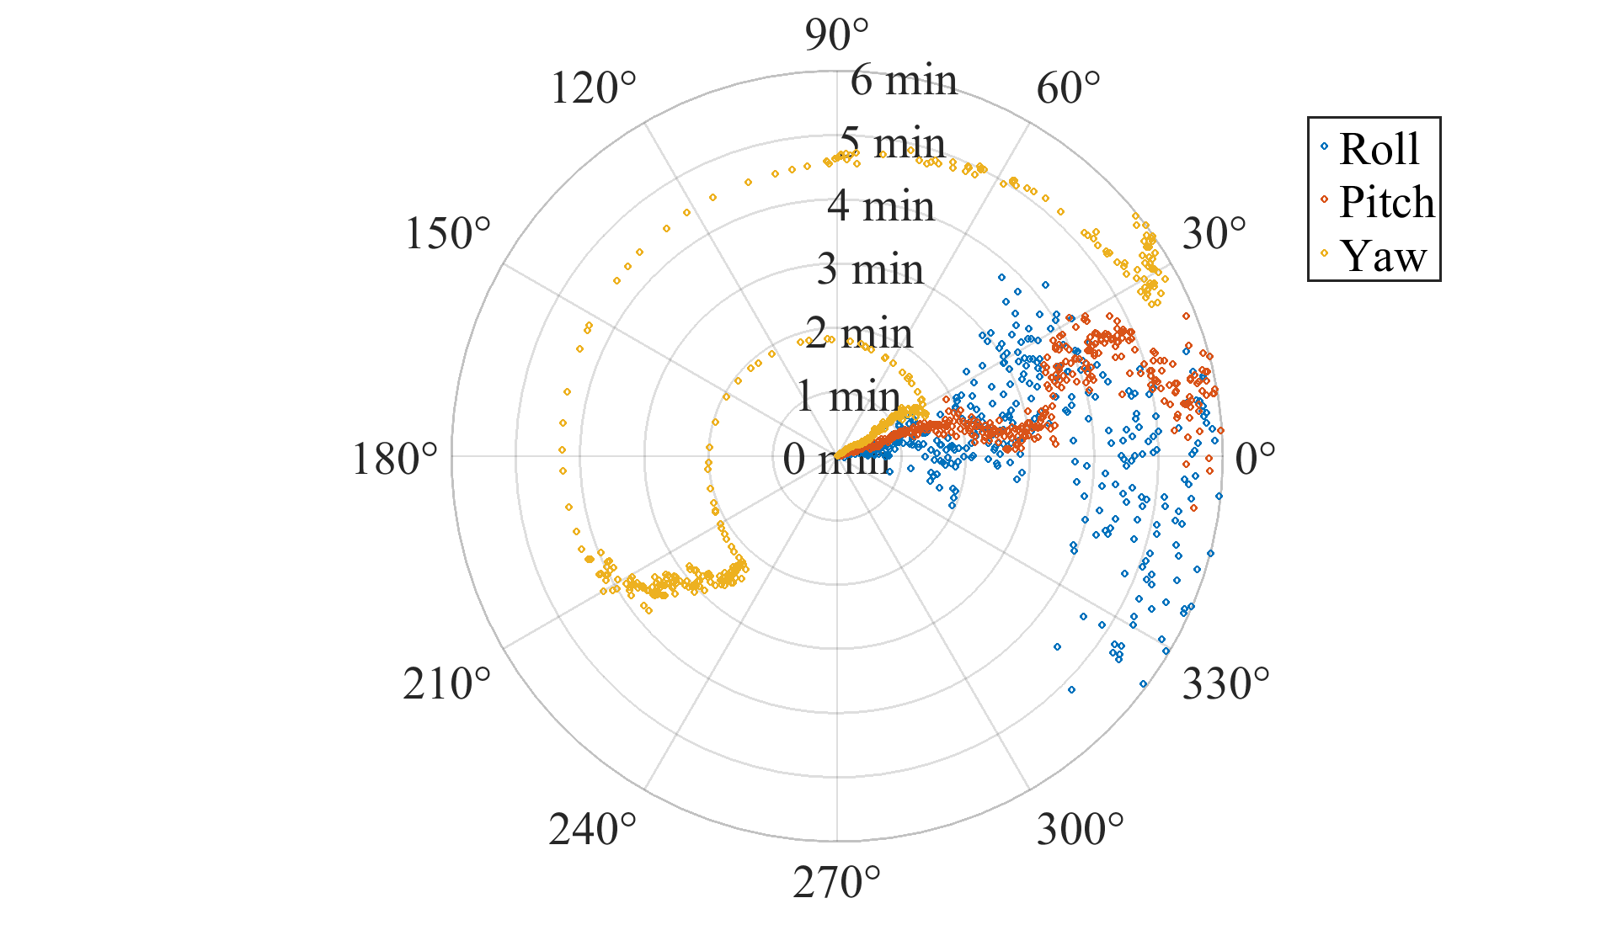
Figure 7: Euler angles during the first six minutes
The multi-antenna approach shows a good estimation of the attitude of the ship. Roll varies the most that is by about 30 degrees which is to be expected since the two GNSS antennas at the back of the ship are only four meters apart and the mean HPE is larger than one meter. Pitch has smaller variance with the largest deviations occurring during the sixth minute. Yaw seems to be the most reliable angle and only has little variance which implies a reliable heading. These observations are in line with the results from section 3.1. Of course, this should be confirmed by the compass data or IMU.
In contrast to the previous subsection, a closer look is now taken at the passing of the waterway lock. Figure 8 shows the Euler angles during that period of time. One can see that only two Euler angles seem to be reliable with pitch and yaw having increased variance starting from minute 28. Roll is unpredictable during the passing of the waterway lock. The same phenomenon occurs during the passing of the bridges where even pitch and yaw are unreliable. This suggests that the precision of the attitude quaternion is heavily affected by multipath and NLOS.
These initial results indicate that for a reliable calculation of the attitude using the multi-antenna approach either the distance of the antennas must be sufficiently large as in the previous scenario or only environments with little to no obstructions can be used to determine accurate Euler angles.
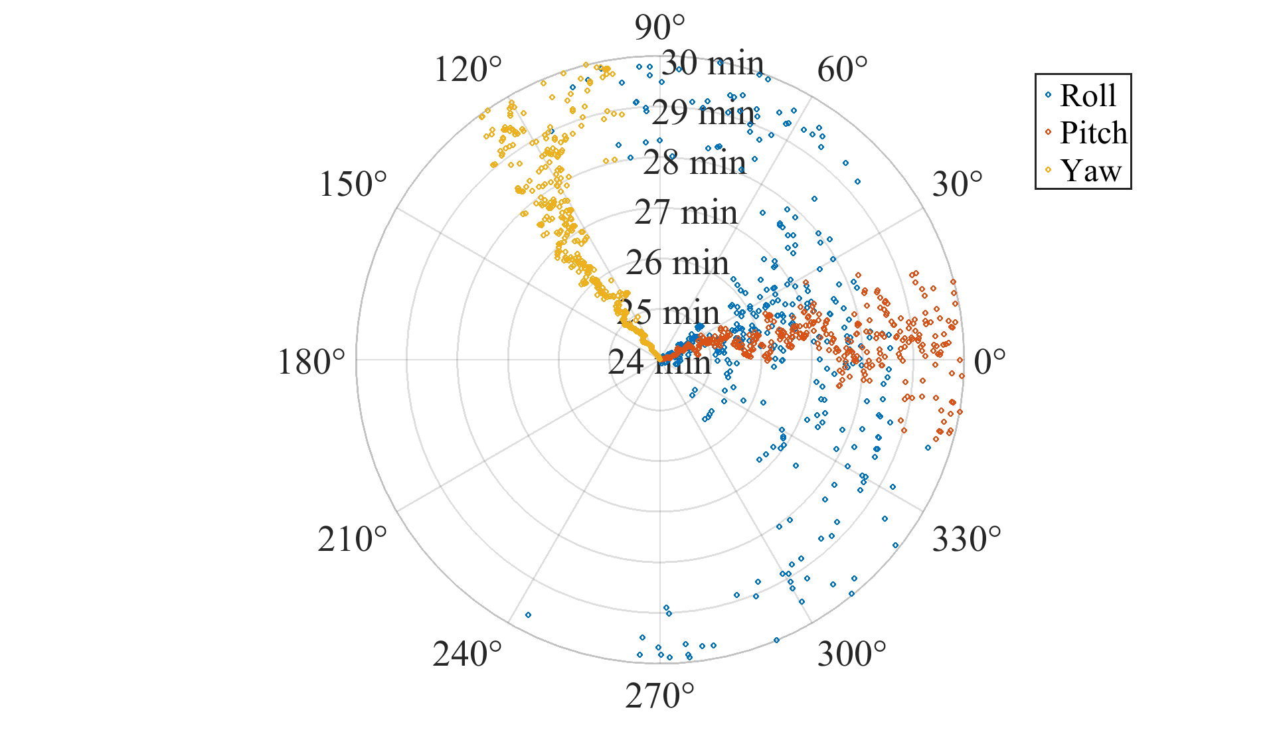
Figure 8: Euler angles during passing of the waterway lock

Summary & Outlook
The work presented a multi-antenna GNSS approach where the position, the receiver clock offsets as well as the attitude of a ship with at least three independent GNSS antennas are calculated in one weighted LS scheme. The mathematical framework, as well as a short explanation of the numerical methods used, was described in the first chapter. The developed methods were tested with real measurement data from two different scenarios using different weighting schemes.
The results looked promising with the multi-antenna approach having better results than the single-antenna approach in the mean as well as in the largest HPE. Furthermore the calculated attitude was reliable in non-obstructing environments. Also, the quality of the attitude quaternion has to be verified using an independent measurement such as IMU or compass data for difficult such as the one on the Moselle River.
Still the maximum HPE is still too large in difficult environments. One way to lessen the impact of faulty observation is the use of robust methods (Knight, 2009) which can help when there are redundant observations such that single observations can be down weighted or even discarded. This would fit the multi-antenna approach since it needs fewer observations than the single-antenna approach for multiple antennas. Another option would be to combine the positioning data calculated by the multi-antenna approach with inertial data using an extended or unscented Kalman filter. Further redundancy could be achieved by using additional GNSS such as GLONASS or Galileo.
Other interesting topics are the theoretical multi-antenna observability, the interpretation of the Jacobian as the geometry matrix and the related dilution of precision (DOP) to predict larger positioning errors.

References
Borre, K. and Strang, G. (2010). Algorithms for Global Positioning. Wellesley-Cambridge Press.
Horn, B.K.P. (1987). Closed-form solution of absolute orientation using unit quaternions. Journal of the Optical Society of America A, 4(4), pp. 629-642
Knight, N.L. and Wang, J. (2009) A comparison of outlier detection procedures and robust estimation methods in GPS positioning. Journal of Navigation, 62, pp. 699-709
Kuusniemi, H. and Lachapelle, G. and Takala, J. (2004). Reliability in personal positioning. Proceedings of GNSS 2004 Conference, Rotterdam, May 16-19.
Ude, A. (1998). Nonlinear least squares optimisation of unit quaternion functions for pose estimation from corresponding features, 14th International Conference on Pattern Recognition, Brisbane, Australia, August 16-20, pp. 425-427
Wang, J. and Wang J. (2007). Mitigating the effect of multiple outliers on GNSS navigation with M-estimation schemes. IGNSS Symposium, The University of New South Wales, Sydney, Australia, December 4-6
Wang, J. and Stewart, M.P. and Tsakiri, M. (1998). Stochastic modelling for static gps baseline data processing. Journal of Surveying Engineering, 124, pp 171-181.
Ziebold, R. and Lanca., L. and Romanovas, M. (2017), On Fault Detection and Exclusion in Snapshot and Recursive Positioning Algorithms for Maritime Applications, European Transport Research Review, 9(1)

