Methodology for determining Pseudo-range noise and multipath models for a multi-constellation, multi-frequency GBAS system

G. Rotondo⁽¹⁾, P. Thevenon⁽¹⁾, C. Milner⁽¹⁾, C. Macabiau⁽¹⁾, M. Felux⁽²⁾, A. Hornbostel⁽²⁾, S. Circiu⁽²⁾
⁽¹⁾Ecole Nationale de L’Aviation Civile
7 Av. E. Belin CS 54005 Toulouse 31000 France
rotondo@recherche.enac.fr
⁽²⁾ Deutsches Zentrum für Luft- und Raumfahrt e.V.,Institute of Communications and Navigation,
Oberpfaffenhofen, 82234 Wessling, Germany
- ABSTRACT
The Ground Based Augmentation System (GBAS) is being studied as a potential means to provide Category II/III precision approach operations. The current technology, the Instrumental Landing System (ILS) is expensive to maintain and suffers from multipath effects which inhibit capacity in all-weather conditions. The GBAS Approach Service Types (GASTs) have been defined to apply to the various levels of vertically guided approach for which up to GAST C relating to Category I precision approach have been standardized. GAST D is under development to support Category II/III precision approaches using the L1C/A signal of the GPS constellation. A GAST F concept is being developed within the SESAR framework on the basis of a multi-constellation t (GPS and GALILEO) multi-frequency environment (L1/L5 and E1/E5a). In order to assess which processing models are to be selected for the GAST F solution, the error models for the new signals must be developed taking into account the impact of the antenna and receiver. This paper presents the analysis of the noise and multipath characterisation using real measurements taken at an experimental ground station.
- INTRODUCTION
The ILS is used for guiding aircraft on final approach during precision approach operations at almost all the major airports worldwide. The ILS whilst not expensive to install requires frequent and expensive maintenance. Furthermore, the system can only support a straight-in approach trajectory for a single runway end, such that multiple installations for one airport are required to support multiple runways [1]. Known issues also include multipath caused by uneven ground surface or other aircraft on the airport surface which limit the capacity by restricting separation minima. Using the Global Navigation Satellite Systems (GNSS) with the GBAS could provide the safe and reliable guidance required with greatly improved flexibility in the definition of approach tracks. Moreover, GBAS could be a more cost effective solution since only one ground subsystem installation could be used to support multiple runway approaches at a single or potentially multiple aerodromes. The GBAS enhances the core constellation by providing differential corrections and integrity monitoring Different types of services were developed classified with the acronym GBAS Approach Service Type (GAST), with GAST C supporting the Category (CAT) I precision approach type using Single Frequency (SF) and Single Constellation (SC) position solution. GAST D is designated for the Category II/III precision approach operations utilizing the L1C/A signal of the Global Positioning System. With the advent of GAST D, a secondary shorter smoothing filter time constant of 30s has been introduced to limit the maximum residual differential ionospheric error, whilst GAST C is based on a 100s time constant [1]. Despite this, the primary threat to GBAS users remains the gross ionospheric differential error induced by strong gradients. GBAS like all differential navigation systems relies on strong spatial correlation of errors such as this ionospheric delay between the ground reference stations and aircraft, such that they may be mitigated through the broadcast of corrections. However, extreme ionosphere storms, causing large ionosphere differential errors must be protected against and monitoring for such threats inevitably impacts on continuity and availability, potentially resulting in a degradation of service. One means to overcome this problem is to use the signals on Multiple Frequencies (MF) to form combinations which partially or totally remove the delays caused by the ionosphere [2] [3]. Furthermore, the additional satellites available in the Multiple-Constellation (MC) environment will significantly improve performance by adding geometric redundancy. Dual frequency techniques have been investigated in previous work [4] [5], leading to two smoothing algorithms, Divergence Free (D-free) and Ionosphere Free (I-free) smoothing. The differences between the two algorithms relate to the level of mitigation of the ionospheric delay and the resulting noise inflation of the final observables. The I-free technique removes the ionosphere delay in its entirety but at the cost of increased noise on the observable used for positioning. This is achieved through combining both the code and phase measurements on two frequencies. The D-free technique removes only the part of the ionospheric delay relating to the transient temporal divergence, but no increase in the standard deviation of the noise and multipath over the single frequency smoothing output occurs [4] [5].

These techniques can thus be used to mitigate the ionosphere and provide Cat II/III services when the GAST D service would be unavailable (under ionospheric gradient conditions or under poor geometry conditions). The SESAR 15.3.7 project is developing the GAST F concept through the investigation of these processing methodologies amongst others. In order to assess accurately the performance which may be achieved, the error model for the GALILEO E1 signal, the Galileo E5a signal and the GPS L5 signals must be determined. It is important to determine this firstly at the raw pseudorange level before addressing the impact of smoothing. Furthermore, different smoothing time constants and correction update rates are being considered within the SESAR framework which will require newly characterized models than those presented within the MOPS and SARPs [6] [7]. In addition, new GAST F constraints regarding the antenna environment for the ground installation and on the tracking configuration on the receiver may be defined which would modify the impact of noise and multipath on the measurement.
- CURRENT ERROR MODEL
The error model of a GBAS is composed by different errors contributing to the total error model. The non-aircraft contribution of the residual error is given in [6] and [8] by the formula:
${RMS}_{pr ground,GPS}\left(θ_{i}\right)≤\sqrt{\frac{1}{M}{\left(a_{0}+a_{1}e^{-\frac{θ_{i}}{θ_{0}}}\right)}^{2} +{\left(a_{2}\right)}^{2}}$ | (1)
Where:
- M is the number of the receivers in the ground subsystem.
- $θ_{i}$is the elevation angle for the $i^{th}$ ranging source.
- The values of $a_{0}, a_{1},a_{2}$ and $θ_{0}$ are given in Table 1 [6].

The main contribution to this type of error is given by noise and multipath at the ground station, other sources of error are due to residual atmospheric error due to the physical separation between the ground station and the aircraft
- NOISE AND MULTUPATH EVALUATION
The development of a new GBAS service, GAST F, requires the knowledge of the error models for each signal used over the two constellations. The model proposed for until now is adapted only for the GPS L1 signal and considers a smoothing filter time constant of 100 seconds. In GAST F new possible processing options should be used and consequentially different smoothing time constant, the evaluation of the errors before the smoothing filter in this case can provide precious information to the user.
The evaluation of the multipath+noise on L1 has been done using following the formula of the Code-Carrier (CMC) with Divergence-Free combination of the phase measurement [4]. This particular combination of code and dual frequency phase measurement is composed mainly of the noise and multipath error on the code measurement.

$$CMC_{L1}=ρ_{1}-ϕ_{1}+\frac{2}{α}\left(ϕ_{1}-ϕ_{2}\right)$$ | (2)
Where:
- $ρ_{1}$ is the code measurement on L1;
- $ϕ_{1}$ and $ϕ_{2}$ are the phase measurement on L1 and L2
- $α=1-\frac{f_{1}^{2}}{f_{2}^{2}}$, $f_{1}$and $f_{2}$ are the frequencies of the signals on L1 and L2.
When applying directly this formula, it is possible to see some large errors affecting the CMC, which is not representing the multipath or the noise error, but is in fact due to phase ambiguity in Eq. $REF _Ref401659998 \backslash h$(2). This effect is visible Figure 1.

Table 1 – Non-Aircraft Elements Accuracy Requirement
Ground Accuracy Designator | $$θ_{i}$$  (degrees) | $$a_{0}$$  (meters) | $$a_{1}$$  (meters) | $$a_{2}$$  (meters) | $$θ_{0}$$  (degrees)
A | >5 | 0.5 | 1.65 | 0.08 | 14.3
B | >5 | 0.16 | 1.07 | 0.08 | 15.5
C | >35 | 0.15 | 0.84 | 0.04 | 15.5

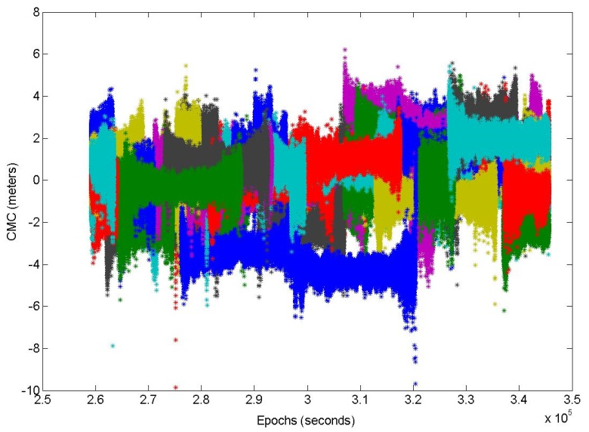
Figure 1 – Multipath & Noise Evaluation on L1

In order to have the correct evaluation of the multipath+noise on the L1 and L5 signals, the following work has been done:
- Identify groups of data corresponding to a continuous tracking of the signal.
- Search inside each group of data for possible cycle slip comparing the predicted phase measurement, Eq. (3), and the real one [10]:
$${\hat{Φ}}_{k}=Φ_{k-1}+\frac{{\dot{Φ}}_{k}+{\dot{Φ}}_{k-1}}{2} Δt$$ | (3)
Where
- $\hat{Φ}$is the predicted phase measurement
- $Φ$ is the real phase measurement.
- $\dot{Φ}$ is the Doppler measurement
- $k$ is the epoch index
- $Δt$is the interval between the $k^{th}$ measurement and the previous one.
The cycle slip is detected by comparing the value of the real and predicted phase measurement, the threshold has been set at 3 cycles.
From each CMC series, according to the group of data, the mean value of the CMC is removed in order to compensate for the possible phase ambiguity over the measurement. In Figure 2 it is possible to see that the cycle slips and the phase ambiguity are removed from the CMC.

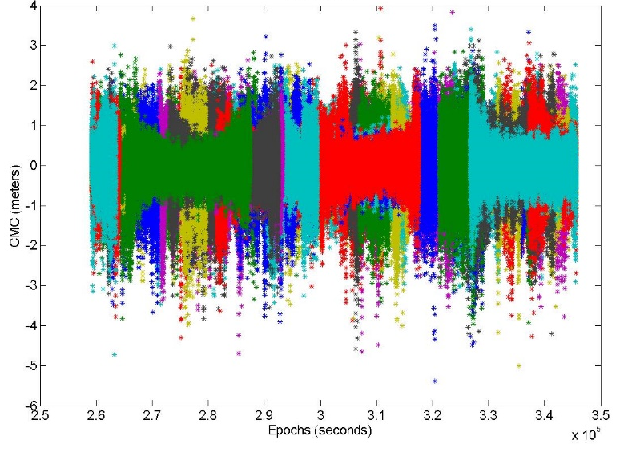
Figure 2 – Multipath & Noise on L1 Corrected for the Phase Ambiguity

Once that the CMC has been computed, the modelling of the error for each satellite and for a 1° elevation bin is done. A second-order auto-regressive model is used because it is a more realistic representation of the noise+multipath signal, in fact it takes into account the time correlation series. The representation of the signal just using sigma as representation of the standard deviation and considering it as white noise is a too optimistic representation for processing purposes. The AR model is represented by the following formula [11]:

$$Sp\left(t\right)=a_{1}*S\left(t-1\right)+a_{2}*S\left(t-2\right)+ε$$ | (4)
Where
- $Sp$is the predicted signal and S is the real signal
- $a_{1}$and $a_{2}$are the coefficient
- $ε$ is a Gaussian noise, named the driving noise
The goal of the modelling process is to estimate the parameters $a_{1},a_{2}, var\left(ε\right)$ for each elevation bin. Different Matlab functions are used in order to evaluate the a1 and a2 parameters of the multipath and the variance of the driving noise, then a comparison between the function has been done on order to check possible differences. They are all computing the same parameters, but using different methods.
LPC, Linear Predictor Coefficients. This function find the coefficients of N-order forward linear prediction and the variance of the driving noise.
ARCOV(data,order) Estimate AR model parameters using covariance method and the variance of the driving noise.
ARYULE(data,order) Estimate autoregressive (AR) all-pole model using Yule-Walker method and variance of the driving noise.
ARMCOV (data,order) Estimate AR model parameters using modified covariance method and compute the variance of the driving noise.
ARBURG (data,order) Estimate AR model parameters using Burg method and compute the variance of the driving noise.
These different methods all estimate the parameters of an AR model, but use different computation techniques. The following investigation aims at determining if one of these methods is more appropriate to the targeted kind of data.
- RESULTS
The methodology explained in chapter 4 has been applied on a series of measurement collected at Braunschweig airport by DLR corresponding to a data collect of the 9th July 2014. The first observation available is at 00h 00’ 00” and the last observation is at 23h 59’ 59”, the interval between the observations is 0.5 seconds. The antenna model is a Leica AR-25 choke ring antenna and they are located at the positions given in Table 3.
Table 2 – Reference Receiver Locations
Indicator | Latitude[°] | Longitude[°] | Receiver Type
BR01 | 52.321444 N | 10.543339 E | Javad Delta
BR02 | 52.322324 N | 10.554618 E | Javad Delta
BR03 | 52.317001 N | 10.567265 E | Javad Delta
BR04 | 52.321269 N | 10.564586 E | Javad Delta

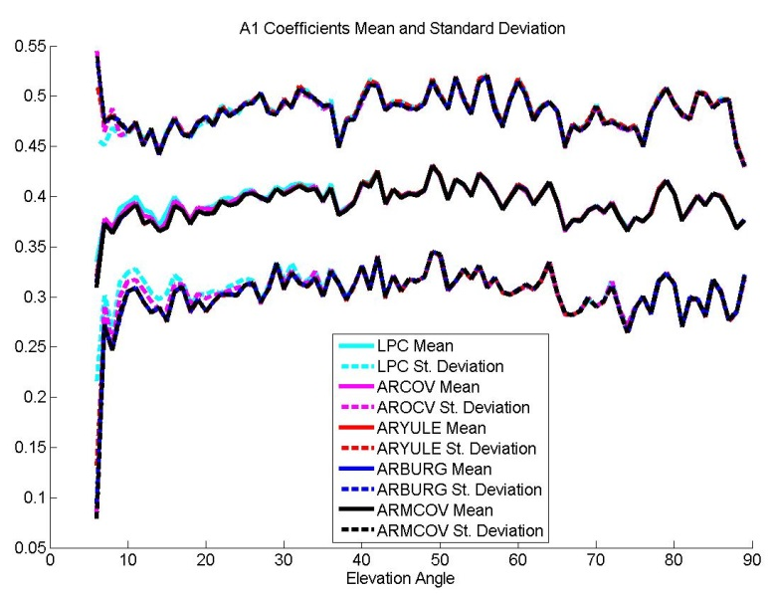
Figure 3 - A1 Coefficients: Mean Values and Related Standard Deviation
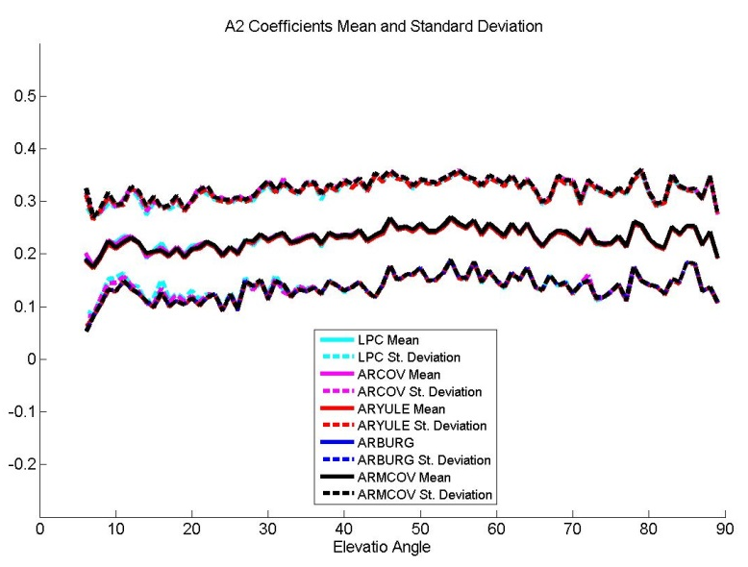
Figure 4 – A2 Coefficients: Mean Values and Related Standard Deviation
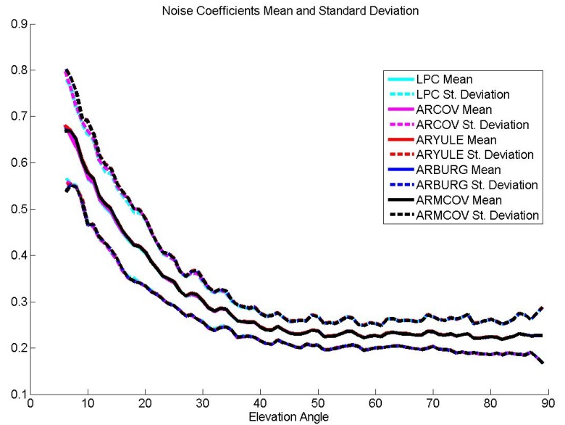
Figure 5 – Noise Mean Values and Related Standard Deviation for Each Elevation Bin

From the analysis of the previous figures, it is possible to assess that for the analyzed data there are no differences in the coefficients computed with the different Matlab functions and even the standard deviation is similar for all of them; for this reason in the next figures just the LPC function will be considered. In order to be sure that the computed coefficients and variance of the driving noise are consistent, the real signal and the one generated by the use of the model parameters are compared in Figure 6, and an analysis if the autocorrelation function is shown in Figure 7. These plots show that the coefficients of the model reflects the properties of the real signal.
The choice of the model order derives from the analysis of the Final Prediction Error (FPE), the Akaike Information Criterion (AIC) and the Criterion Autoregressive Transfer (CAT).
$$FPE\left(k\right)=\frac{N+k}{N-k} C$$ | (5)
$$AIC\left(k\right)=N \ln\left(C\right)+k \ln\left(N\right)$$ |  | (6)
$$CAT\left(k\right)=\frac{N}{N-k} C$$ | (7)
Where
- $k$is the model order
- $C$is the power of the prediction error
- $N$is the number of signal samples

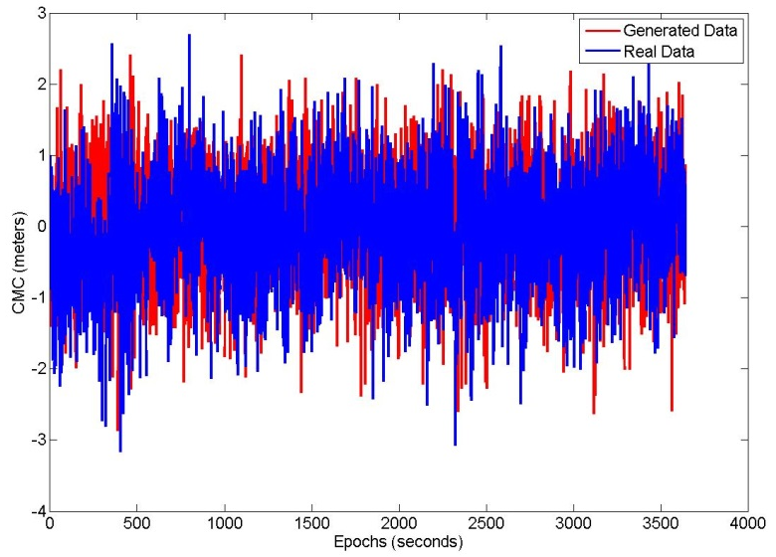
Figure 6 – Real CMC and Generated CMC for Satellite PRN 24 and 6° Elevation Bin
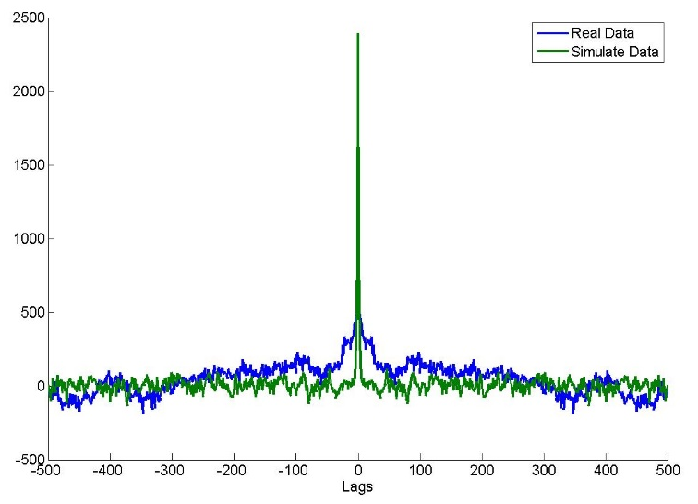
Figure 7 – Autocorrelation Function for Satellite PRN 24 and 6° Elevation Bin (zoom from -500 to 500 Lags)

These criteria provides an estimation of the prediction error power, and are commonly used to determine the order of an auto-regressive model. Figure 8 shows that the practical minimum order is around 5. However, the difference of the error criteria between the second and the fifth order model is small (approximately between 3-4% for each criteria). Therefore, a 2nd order model seems reasonably close to represent the real signal, and has the benefit to keep the model simpler than a higher order model.
In Figure 9, the comparison of the coefficients standard deviation confirms the choice of the model. The standard deviation of the a1 coefficients for the 1st order model is larger than the other model orders, and from the second order, the standard deviation starts to be almost similar. The values of the a2 standard deviation are similar for all the order model analyzed. The standard deviation of the driving noise is similar for all the model orders analyzed.

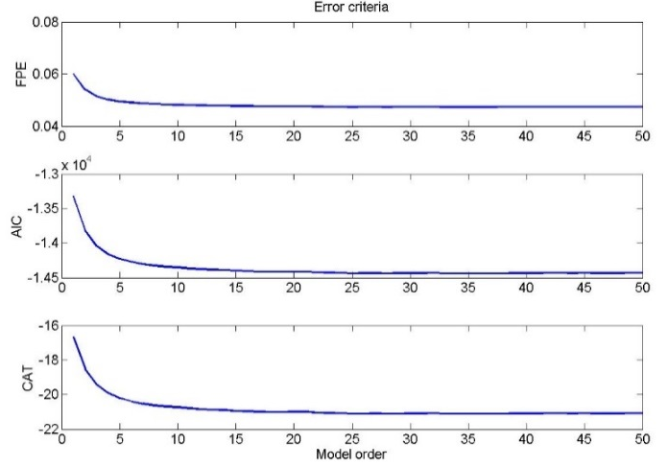
Figure 8 – Error Criteria for Satellite PRN 2 and Elevation angle bin 40°/42°
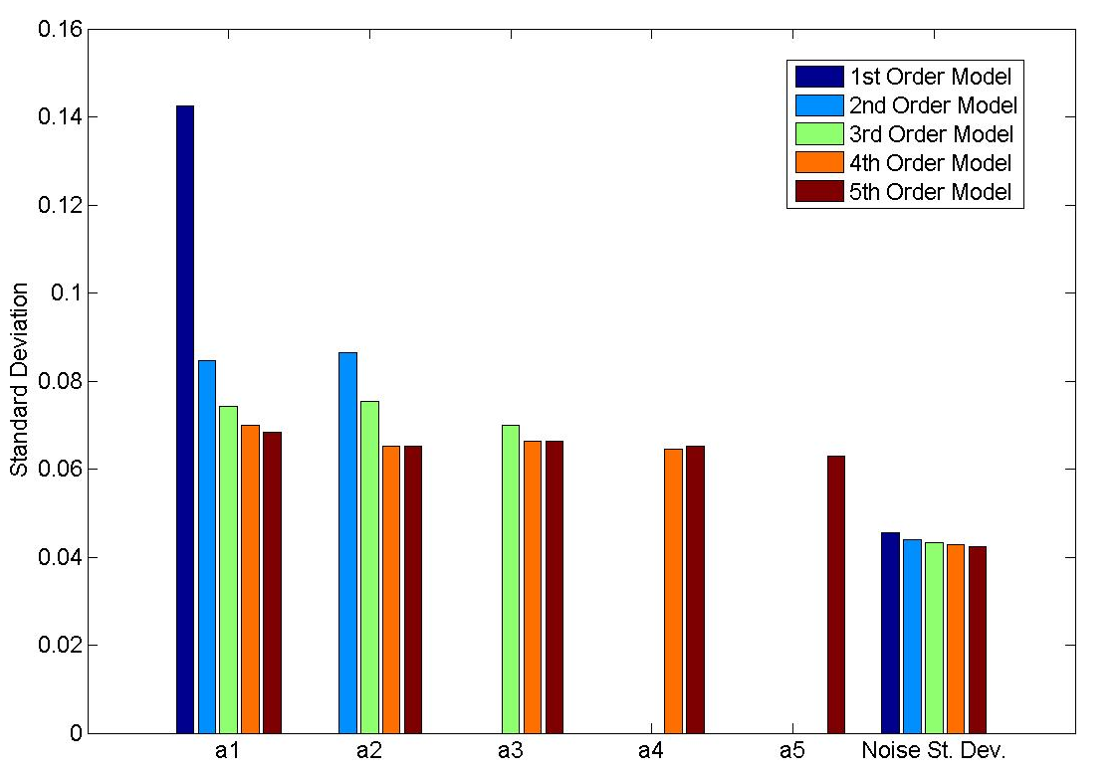
Figure 9 – Coefficients and Driving Noise Standard Deviation for Different Model order

- CONCLUSIONS
We have presented a proposal for the estimation of noise and multipath using a D-Free combination. In order to remove possible phase ambiguity and cycle slip on the phase a phase based cycle slip detector has been implemented, finally the CMC was modelled using a second order autoregressive method. The application of this methodology to a set of data from a single ground receiver has provided good results, however it is important to note that this results are not representative of a GBAS ground station because they are not conform with the siting antenna and receiver constraints. One advantage of this method is that it provides more information about the noise and multipath temporal correlation than just describing the time series by its total standard deviation.
- FUTURE WORKS
The next steps of this work consists in the application of the methodology to a large set of data and in particular to GPS L1 and L5 and GALILEO E1 and E5a, which will be the signal of interest of a GAST F GBAS system. The second step will be the analysis of the same signal applying the I-Free combination and, finally, the analysis of the two combinations after the smoothing filter using different smoothing time constant in order to verify the impact of this on noise and multipath. The correct model of noise and multipath standard deviation vs. elevation will then be used for other measurement processing in the GAST F GBAS system, such as the computation of the Protection Levels.
- REFERENCES
- Dautermann, T., Felux, M., Grosch, A., (2011). Approach service type D evaluation of the DLR GBAS testbed. GPS Solutions, Springer-Verlag 2011.
- Circiu, M-S., Felux, M., Remi, P., Yi, L., Belabbas, B., Pullen, S., "Evaluation of Dual Frequency GBAS Performance Using Flight Data," Proceedings of the 2014 International Technical Meeting of The Institute of Navigation, San Diego, California, January 2014, pp. 645-656.
- H. Konno “Design of an aircraft landing system using dual-frequency GNSS,” Ph.D. thesis, December 2007
- Konno, Hiroyuki, "Dual-Frequency Smoothing for CAT III LAAS: Performance Assessment Considering Ionosphere Anomalies," Proceedings of the 20th International Technical Meeting of the Satellite Division of The Institute of Navigation (ION GNSS 2007), Fort Worth, TX, September 2007, pp. 424-437.
- Hwang, P. Y., McGraw, G. A., & Bade, J. R. (1999). Enhanced DifferentialGPS Carrier-Smoothed Code Processing Using Dual-Frequency Measurements. Journal of The Institute of Navigation, Vol 46 number 2.
- RTCA DO245A (2004) Minimum aviation system performance standards for the local area augmentation system (LAAS), Tech Rep, DO245A, RTCA.
- ICAO NSP May 2010 WP 59, "Development Baseline SARPs Proposal", presented by Tim Murphy, Montreal, 17-28 May 2010.
- ICAO. (2006). International Standards and Recommended Practices, Annex 10 to Convention on International Civil aviation, Volume I, Radio Navigation Aids, Sixth Edition.
- Booth, J., Murphy, T., Clark, B., Liu, F. (2000). Validation of the Airframe Multipath Error Allocation for Local Area Differential GPS. Proceedings of the IAIN World Congress in association with the U.S. ION ANNUAL MEETING, 26-28 June 2000, San Diego, CA
- Wang, C. (2003). Development of a Low-Cost GPS-based Attitude Determination System. Ph.D. Thesis, Univursity of Calgary, June 2003
- Jackson, L.B., Digital Filters and Signal Processing, Second Edition, Kluwer Academic Publishers, 1989.
- Ljung, L. System Identification: Theory for the User, Upper Saddle River, NJ, Prentice-Hal PTR, 1999.

