Conceptual design of an interplanetary CubeSats system for space weather evaluations and technology demonstration

**M.A. Viscio(1), N. Viola(1), S. Corpino(1), C. Circi(2), F. Fumenti(3) and S. Fineschi(4)**

(1) Politecnico di Torino, Corso Duca degli Abruzzi, 24, 10129 Torino, Italy

(2) University “La Sapienza”, Via Salaria 851, 00138 Rome, Italy

(3) DLR Institute of Space Systems, Robert-Hooke-Str. 7, 28359 Bremen, Germany

(4) Osservatorio Astrofisico di Torino, Strada Osservatorio 20, 10025, Pino Torinese (To), Italy

Corresponding Author e-mail address: maria.viscio@polito.it

Abstract

The paper deals with the mission analysis and conceptual design of an interplanetary 6U CubeSats system to be implemented in an Earth-Sun Lagrangian Points mission for solar observation and in-situ space weather measurements.

Interplanetary CubeSats could be an interesting alternative to big missions, to fulfill both scientific and technological tasks in deep space, as proved by the growing interest in this kind of application in the scientific community and most of all at NASA. Such systems allow less costly missions, due to their reduced sizes and volumes, and consequently less demanding launches requirements.

The CubeSats mission presented in this paper is aimed at supporting measurements of space weather. The mission envisages the deployment of a 6U CubeSats system in one of the Earth-Sun Lagrangian Points, where solar observations for in situ measurements of space weather to provide additional warning time to Earth can be carried out.

The proposed mission is also intended as a technology validation mission, giving the chance to test advanced technologies, such as telecommunications and solar sails, envisaged as propulsion system. Furthermore, travelling outside the Van Allen belts, the 6U CubeSats system gives the opportunity to further investigate the space radiation environment: radiation dosimeters and advanced materials are envisaged to be implemented, in order to test their response to the harsh space environment, even in view of future implementation on other spacecrafts (e.g. manned spacecrafts).

The main issue related to CubeSats is how to fit big science within a small package - namely power, mass, volume, and data limitations. One of the objectives of the work is therefore to identify and size the required subsystems and equipment, needed to accomplish specific mission objectives, and to investigate the most suitable configuration, in order to be compatible with the typical CubeSats (multi units) standards.

The work has been developed as collaboration between Politecnico di Torino, University “La Sapienza” (Rome), “INAF - Osservatorio Astrofisico di Torino” (Astrophysical Observatory of Torino) and DLR (Deutsches Zentrum für Luft- und Raumfahrt) in Bremen.

Keywords: CubeSats, interplanetary mission, space weather, solar observation

INTRODUCTION

A large number of CubeSats have already been developed and launched into Earth orbit; however none have accomplished an interplanetary mission. Since big missions are usually very costly, relying on CubeSats could be an interesting alternative to accomplish both scientific and technological tasks in deep space, as proved by the growing interest in this kind of application in the scientific community and most of all at NASA.

Even after decades of study and spacecraft visits, many planetary science goals remain, and among them one of the most exciting is the search for signs of past or present life on the surface or subsurface of a handful of solar system planets and moons. Of equal interest is asteroid characterization for future resource extraction. The newest field of planetary science is the discovery and characterization of exoplanets, planets orbiting stars other than the sun.

Besides the high value scientific return, interplanetary CubeSats can be also exploited as support for future human exploration of the solar systems as well as test-bed for advanced technologies (e.g. solar sails). In this regard they can be used to provide solar storm advance warning, radio­quiet zone Mapping of Earth­Moon L2 region, Lunar surface mapping, asteroids mapping, etc.

The CubeSats mission presented in this paper is aimed at supporting measurements of space weather that represents quite a critical issue especially for what concerns the human exploration of space beyond Earth orbit where the protection of the Earth magnetic field is not available anymore. The mission envisages the deployment of a 6U CubeSats system in one of the Earth-Sun Lagrangian Points, where solar observations for in situ measurements of space weather to provide additional warning time to Earth can be carried out. The proposed mission is also intended as a technology validation mission, giving the chance to test advanced technologies, such as telecommunications and solar sails, envisaged as propulsion system. Furthermore, the potentialities of this kind of system as support to future exploration missions are considered. In this regard, travelling outside the Van Allen belts, the 6U CubeSats system gives the opportunity to further investigate the space radiation environment: radiation dosimeters and advanced materials are envisaged to be implemented, in order to test their response to the harsh space environment, even in view of future implementation on other spacecrafts (e.g. manned spacecraft).

The work has been developed as collaboration between Politecnico di Torino, University “La Sapienza” (Rome), “INAF - Osservatorio Astrofisico di Torino” (Astrophysical Observatory of Torino) and DLR (Deutsches Zentrum für Luft- und Raumfahrt) in Bremen. The AeroSpace Systems Engineering Team, ASSET, at the Department of Mechanical and Aerospace Engineering of Politecnico di Torino has been working for almost a decade at small satellites programs. In February 2012 e-st@r was successfully injected into Low Earth Orbit (LEO) by Vega Launch Vehicle. E-st@r is a cubesat, developed by undergraduate and most of all by graduate and PhD students under the supervision of researchers and professors, with educational and technological/engineering objectives [1]. The e-st@r program followed the PiCPoT program, which was developed at Politecnico di Torino in the 2000s and ended with the unfortunate launch of PiCPoT nano-satellite in 2006, which never reached LEO because of a failure of the launcher [2]. Both PiCPoT and e-st@r programs represent a valuable heritage for the current small satellites activities at Politecnico di Torino [3].

The paper starts from the definition of the mission (see section 1), in terms of mission statement, mission objectives, requirements and mission analysis. Then it focuses on the 6U CubeSats system (see section 2), describing its configuration and analyzing the subsystems and main equipment composing it, and on its technological challenges (see section 3). Eventually main conclusions are drawn.

1. Cubesats mission
2. Mission Objectives

According to the typical conceptual design process in Systems Engineering, the mission statement, which is reported hereafter, has been firstly established:

*To perform solar observation and in-situ space weather measurements from an Earth-Sun Lagrangian point region, pursuing a low-cost approach relying on interplanetary CubeSats and providing a platform for advanced technologies test.*

Starting from the mission statement, the mission objectives have been derived. Mission objectives can be split into two different groups:

1. Scientific objectives:

* *to observe the Sun*
* *to perform plasma measurements*
* *to perform radiation measurements*

1. Technological objectives:

* *to develop a low-cost CubeSats platform*
* *to implement solar sail propulsion*
* *to communicate to Earth from very distant region (Earth-Sun L1)*
* *to collect, store, manage and send to Earth large quantity of scientific data.*

1. Mission Requirements

Once the broad goals of the system, represented by the mission objectives, had been identified, the system requirements have been defined. On the basis of the system requirements, the conceptual design process of the 6U CubeSats system has evolved through the mission analysis (section 1.3) and the system architecture, which consists of two main tasks: Functional Analysis (section 2.1) and System Sizing, which is currently under way.

In order to proceed with the sizing of the system the top-level requirements had to be assessed. Hereafter, a summary of the most significant ones is reported.

* Functional requirements
  + The system shall perform an interplanetary mission to the first Earth Sun Lagrangian point.
  + The system shall be provided with interfaces with the launcher.
  + The system shall withstand the launch loads.
  + The system shall withstand the deep space environment.
  + The system shall perform plasma measurement.
  + The system shall take pictures of the Sun.
  + The system shall perform radiations measurements (total ionizing dose).
  + The system shall allow communications with Earth.
    - command data (uplink)
    - telemetry data (downlink)
    - scientific data (downlink)
* Performance requirements
  + The system shall be compliant with 6U CubeSats standards
    - maximum envelope: 20cm x 30cm x 10cm
    - maximum total mass: 6kg
  + The total required power shall not exceed 50W.
  + The max required data rate shall not exceed 500kbps[1].

1. Mission Analysis

The motion of a 6U CubeSats system is studied using the circular restricted three-body problem (CR3BP) approach. Sun and Earth are supposed to move in circular orbits around their center of mass while the CubeSats system, with its negligible mass, is supposed to move in the resulting force field without affecting the motion of the primaries [4, 5, 6]. The CR3BP possesses 5 equilibrium points in which the third body could theoretically stay without requiring any corrective maneuver. Nonetheless only 2 of these 5 points are stable, while the others are characterized by instability. This means that for a third body around an unstable point even a small perturbation can cause its departure making the motion unbounded. The only way to constrain the third body motion in the vicinity of one unstable point consists in using a propulsion system to execute corrective maneuvers and a lot of studies can be found in literature [7, 8, 9, 10, 11]. In this paper the motion around the L1 unstable point is considered envisaging the third body, i.e. the 6U CubeSats system, equipped with a solar sail.

The problem can be described in a Cartesian reference frame *Oxyz* with the origin fixed in the system barycenter, with the *xy-*plane coinciding with the plane of primaries motion and with the *x*-axis oriented along the Sun-Earth direction. Assuming as unity the distance between the primaries, the mean angular rate of the system and the sum of the primaries masses, the motion of the CubeSat can be described in non-dimensional units through the following system of differential equations

where:



denotes the 6U CubeSats system position



denotes the 6U CubeSats system velocity



denotes the system angular rate



denotes the potential function



denotes the mass ratio



denotes the position of the 6U CubeSats system with respect to the Sun



denotes the position of the 6U CubeSats system with respect to the Earth



denotes the sail characteristic acceleration, that is the acceleration provided at 1 AU from the Sun



denotes the unit-vector which is normal to the sail surface.



The sail is supposed to be ideal, i.e. it reflects all the incoming radiation and no deformation are taken into consideration. The attitude of the sail can be described using two angles and and an orthonormal rotating reference frame *Cxvyvzv* as shown in Figure 1.

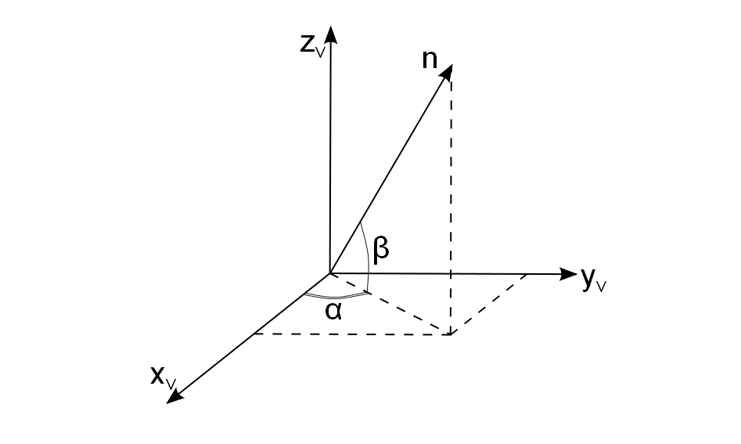

Fig. 1: Solar Sail Attitude

The *Cxvyvzv* frame has the origin in the centre of the sail surface, while the three directions are defined as follows

.



To determine the sail attitude and the satellite path, an optimal control problem has been set and solved through the Direct Collocation with Non Linear Programming (DCNLP) approach [12, 13, 14].

In defining the optimization problem particular attention is deserved by the initial guess used for the trajectory. In the early '80s Richardson was one of the first authors studying approximated solutions of the CR3BP [15]. In his work Richardson showed a viable method to construct the so-called Halo orbits, which are solutions characterized by the equality of the in-plane and out-of-plane motion frequencies. For the L1 point Halo orbits have a period T of approximately 177 days, which is roughly half a year, hence to simulate a one-year CubeSat trajectory tests for 2T have been conducted.

In order to obtain a trajectory as close as possible to a close periodic orbit, the chosen performance index to minimize is the difference between the initial and the final state, evaluated considering both the difference between the positions and between the velocities

.



Constraints have been imposed both on the state vector, bounding the motion in the vicinity of L1, and on the control vector, limiting the sail attitude rates to 5 degrees per day.

It is finally worth pointing out that no Halo station-keeping has been performed; the only request about the motion is to keep it close to the Lagrangian point, hence the resulting optimal trajectory is allowed to be very different from the initial guess.

1. spacecraft configuration
2. Functional analysis

The Functional Analysis is a fundamental tool of the design process to explore new concepts and define their architectures. When systems engineers design new products, they perform Functional Analysis to refine the new product’s functional requirements, to map its functions to physical components, to guarantee that all necessary components are listed and that no unnecessary components are requested and to understand the relationships among the new product’s components [16].

Primary results of Functional Analysis are the functional tree and the product tree: the former identifies the basic functions, which the system has to be able to perform, while the latter individuates all system physical components, which are able to carry out the basic functions. In other words, these components may be the equipment or the subsystems, which make up the whole system.

According to the Functional Analysis, once the basic functions had been identified, the components to perform those functions have been selected by means of the so-called functions/components (or functions/devices) matrix. The functions/components matrix has therefore been used to map functions to physical components. Figure 2 illustrates the functions/components matrix for the complete 6U CubeSats system.

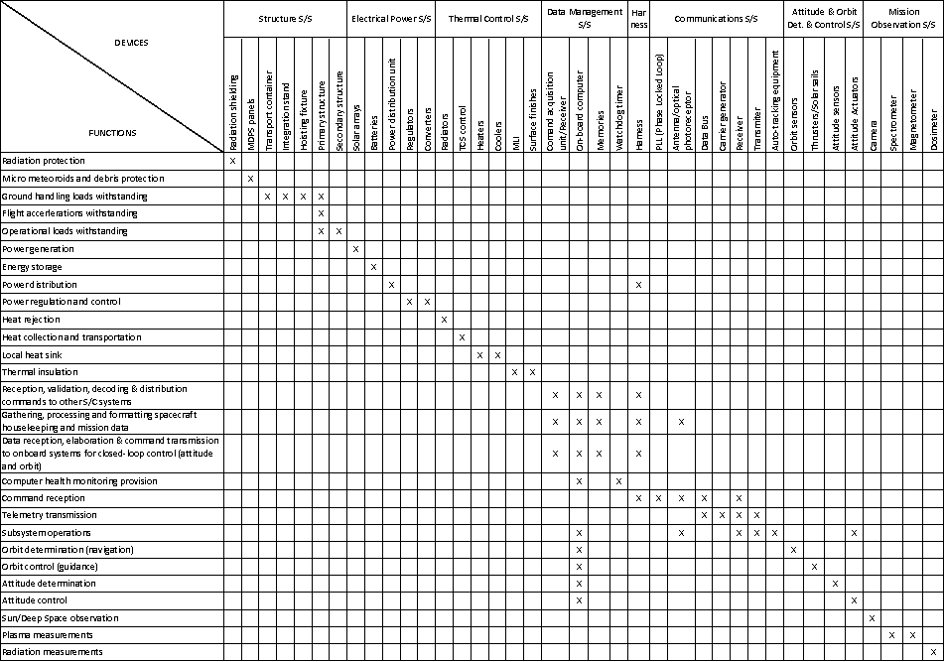

**Fig. 2: Functions/Components Matrix**

As result of the Functional Analysis the assessment of the subsystems and components needed to accomplish the mission has been derived. In summary, the following subsystems compose the 6U CubeSats system:

* structure, which supports all other spacecraft subsystems, and includes the attachment interfaces with the launcher (to be defined);
* electrical power subsystem, which is in charge of providing, storing, distributing and controlling the spacecraft electrical power; it mainly consists of solar cells mounted on the external surfaces of the system as power source , Li-ion batteries for the energy storage and power distribution unit;
* thermal control, to maintain all spacecraft and payload components and subsystems within their required temperature limits for each mission phase; for this mission a passive solution is envisaged;
* command and data handling, which receives, validates, decodes, and distributes commands to other spacecraft systems and gathers, processes, and formats spacecraft housekeeping and mission data for downlink;
* attitude and orbit determination and control subsystem, needed to stabilize the vehicle and orient it in desired directions during the mission despite the external disturbance torques acting on it; solar sails are exploited for orbit control;
* communications, which provides the interface between the spacecraft and the ground systems, transmitting both payloads mission data and spacecraft housekeeping data; for an interplanetary CubeSats mission optical communication is likely to be implemented, in order to be compliant with mission requirements and constraints (dedicated trade-off analyses between RF and optical communications are worthwhile)
* harness;
* mission observation subsystem, which includes the scientific instruments for Sun observation and plasma measurements (see section 2.2).

Besides the allocation of the subsystems, one of the main issues related to CubeSats is how to fit big science within a small package - namely power, mass, volume, and data limitations. One of the objectives of the work is therefore to identify and size the required subsystems and equipment, needed to accomplish specific mission objectives, and to investigate the most suitable configuration, in order to be compatible with the typical CubeSats (multi units) standards.

A reference system able to fulfill the scientific objectives of the proposed mission may consist of:

* 2U occupied by the scientific payloads;
* 2U for the solar sails;
* 1U devoted to telecommunications;
* 1U for the attitude control system and command and data handling.

The following section focuses on the description of the scientific payloads, which occupy up to two of the CubeSats system units.

1. Scientific Payloads

In this section a brief overview of the scientific instruments to be included in the system, according to the mission objectives, is reported.

Specifically, the types of instruments to be considered are:

* Plasma Instruments, for plasma measurements;
* Radiation Dosimeters and Advanced Materials, to investigate the space environment and validate technologies in view of future implementation in human missions;
* Imagers/Cameras, to take pictures of the Sun.

For each instruments class, several options have been considered and among them only the most significant ones have been selected, also according to constraints deriving from the CubeSats standards. In particular, all the scientific payloads shall fit 2U CubeSat sizes (10cm x 10cm x 20cm, 2kg).

Hereafter, the main features of the instruments are discussed and the justification for the selection of specific ones is reported.

1. Plasma Instruments

Two instruments are included in this group, envisaged to perform measurement of the plasma environment.

* + Magnetometer
  + Plasma Spectrometer

The reference magnetometer considered for this mission is a tri-axial magnetometer utilizing Anisotropic Magneto-Resistance (AMR) [17]. It is a low cost magneto-resistive magnetometer designed for use in LEO small satellites and CubeSats, with very low mass and small size. Its main features are listed in table I.

|  |  |  |  |
| --- | --- | --- | --- |
| **Mass** | **Volume** | **Power** | **Data** |
| * Sensor: 15g * Electronics: 150g | * Sensor: 10x10x5mm * Electronics: 90x30x11mm | * Power consumption: 400mW * Power supply: +5V and +15V DC or 28V unregulated option | * Measurement range: +50,000nT to -50,000nT * Sensitivity: 10nT * Update rate: up to 10Hz * Data Rate: 140bps |
| Table I: Magnetometer features | | | |

The reference spectrometer is an Ion and Neutral Mass Spectrometer (INMS) [18, 19], that is a miniaturised analyser designed for sampling of low mass ionised and neutral particles in the spacecraft ram direction.

The key sensor components consist of a collimator/ion filter, an ioniser and a charged particle spectrometer. Particles enter the aperture into the ion filter region where charged particles can be rejected. This is followed by a series of baffles for collimation and further charged particle suppression. Collimated neutral particles are subsequently ionised in the ionizer by a 50 eV electron beam followed by mass selection in the analyser. The spectrometer can be operated in different modes, optimised for ions or neutral particle analysis. The INMS main features are listed in table II.

|  |  |  |  |
| --- | --- | --- | --- |
| **Mass** | **Volume** | **Power** | **Data** |
| Mass: 350g | Envelope: 100x100x50mm (½U) | Power consumption: 500mW | Data Rate: ~23bps |
| Table II: INMS features | | | |

1. Radiation Dosimeters Advanced Materials

The CubeSats mission discussed in this work shall be seen also as a support for future human missions. In this regard it is envisaged to implement advanced materials, coupled with specific radiation dosimeters, in order to test their response to the harsh space environment and validate them in view of future implementation in human systems.

Life on earth is protected from the hazards of the deep space environment by the solar winds, the Earth's atmosphere and the Earth's magnetic field. As human spaceflight refocuses to explore deep-space locations of interest, crews shall face prolonged exposure to three major sources of radiation:

* **Galactic Cosmic Radiation** (GCR): High energy GCR particles (~25MeV - ~20GeV) of all atomic numbers are showered into the galaxy when stars undergo supernova. Approximately 88% of all GCR particles are hydrogen, 10% are helium, and the remaining percentage consists of heavier ions.
* **Solar Cosmic Radiation** (SCR): SCR is composed of two categories of radiation, low energy solar-wind particles that are constantly emitted from the sun (generally considered not to be dangerous), and highly energetic solar particle events (SPE). SPE-based radiation is a consequence of coronal mass ejections that originate from disturbed magnetic regions on the sun's surface.
* **Van Allen Radiation Belts**: The Earth's magnetic field, generated by the motion of the molten iron core of the planet, collect and trap SCR and low-energy GCR ionized particles, creating bands of increased radiation in the vicinity of Earth. Typically, crewed missions spend a small amount of time in the influence of the Van Allen belts, and their contribution to overall crew radiation exposure is comparably small to GCR and SPE sources.

The CubeSats mission represents an opportunity to study the deep space environment, and in particular to test the response of specific materials, which can be used to shield the spacecraft.

The envisioned radiation micro dosimeters [20] are compact hybrid microcircuits which directly measure the total ionizing dose absorbed by an internal silicon test mass. The test mass simulates silicon die of integrated circuits on-board a host spacecraft in critical mission payloads and subsystems. By accurately measuring the energy absorbed from electrons, protons, and gamma rays, an estimate of the dose absorbed by other electronic devices on the same vehicle can be made. The dosimeters’ main features are listed in table III.

|  |  |  |  |
| --- | --- | --- | --- |
| **Mass** | **Volume** | **Power** | **Data (type/quantity)** |
| * Mass: 20 g | * Envelope: 35x25x10mm | * Power consumption: 280mW * Electric I/F: 10 mA at 13-40 VDC | * Measures up to 40 krads * Data Rate: 1 Byte/s |
| Table III: Radiation Micro Dosimeter features | | | |

The dose of radiation accumulated on a system will depend on the shielding capability of the material used to shield. The shielding effectiveness depends on the chemical composition of the material (for example hydrogen is very efficient shielding and therefore materials with high hydrogen concentration shall be preferred), and according to this, very different masses of shielding could be needed, to meet the requirements on the maximum absorbed dose, while considering different materials.

In the CubeSats mission here discussed, two different materials are envisaged to be implemented and tested, through dosimeters’ measurements: Kevlar [21] and High Density Polyethylene (HDPE) [22], which indeed have good shielding performances.

As final configuration, three dosimeters are envisioned, positioned in three different spots. Two of them are coupled with Kevlar and HDPE covers, in order to measure the shielding capabilities of the two materials.

In particular, it is assumed to have two equal tiles having a thickness of 20mm for both materials (each tile is 50x50x20mm, which corresponds to 72g for Kevlar and 48g for polyethylene).

1. Imagers/Cameras

A NanoCam C1U [23] is envisaged to take pictures of the Sun[2]. It is a high performing camera system fitting a single unit cubesat, based on a CMOS technology. Its main features are listed in table IV.

|  |  |  |  |
| --- | --- | --- | --- |
| **Mass** | **Volume** | **Power** | **Data (type/quantity)** |
| * Mass: 170 g | * Envelope: 96x90x58mm | * Power consumption:   + Idle: 360mW   + Image acquisition: 634mW   + Image processing: 660mW * Supply voltage: 3.3V | * CMOS camera * Data Rate: 400kbps |
| Table IV: NanoCam C1U features | | | |

1. technological challenges

The enabling technologies for this kind of mission mainly regard the solar sail control and navigation, deep space tracking and telecommunications.

1. Solar Sails

The solar sail used as propulsion system is not allowed to have a big size, since its design is affected by the requirements dictated from the 6U CubeSats system characteristic small sizes and volumes. In turn, this results in small available thrust acceleration. In this paper a solar sail with characteristic acceleration equal to 0.01 mm/s2 has been taken into consideration. As stated above, the optimal trajectory has been found for a timeframe of 2T, where T denotes the period of the Halo orbit used as initial guess. A sample trajectory obtained from a Halo with *z*-axis amplitude Az = 250000 km is shown in Figure 3. The reference frame *Oxyz* is used, but for easy viewing the origin *O* and the Sun are not included in the figure.

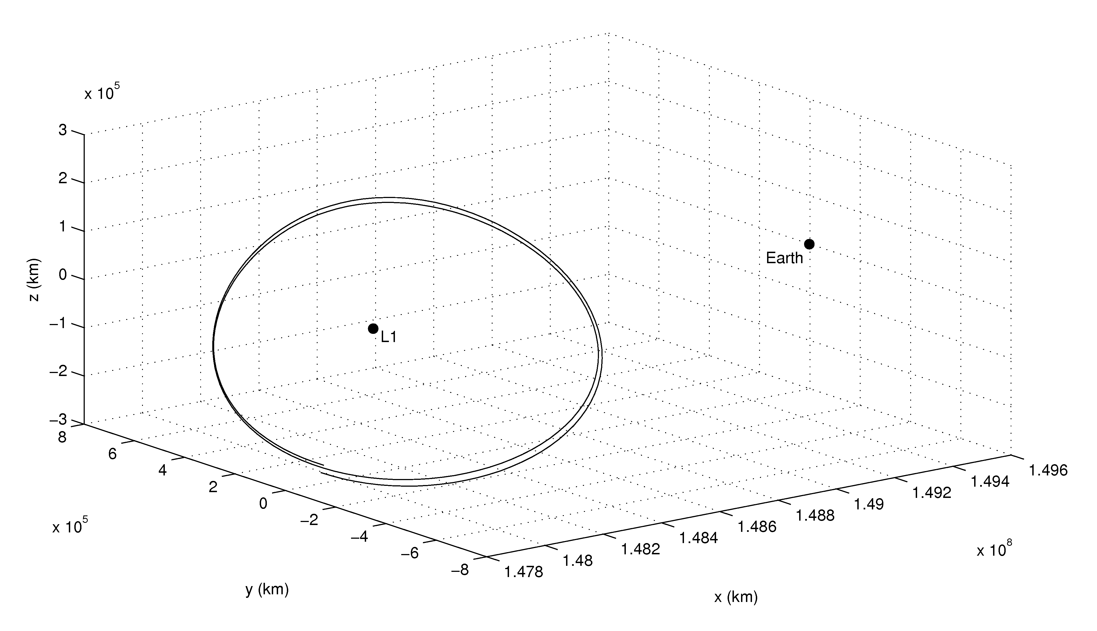

Fig. 3: Optimal trajectory obtained from a Az = 250000 km Halo

1. Communications

When sizing the communications subsystem for a spacecraft traveling very far from Earth, one of the issues to be faced is the choice between radio frequency (RF) and optical communications.

As a matter of fact, laser communications offer many advantages over RF systems. Most of the differences arise from the very large difference in the wavelengths, which at RF are thousands of times longer than at optical frequencies. Optical crosslinks are interesting because they can support higher data rates than RF using relatively small antennas diameters, resulting in lower system masses. On the other hand, laser communications typically use narrow optical beams and therefore they are difficult to acquire and point accurately, requiring more complex pointing mechanisms.

Due to the long distance and the small CubeSats standard sizes, optical communication is to be preferred to enable very compact, low power uplink/downlink over interplanetary distances and allow a good scientific data transfer capability to Earth.

conclusions

The paper presents a 6U CubeSats system interplanetary mission to one of the Earth-Sun Lagrangian point. CubeSats are interesting alternatives to big satellites, which are usually very costly, since they allow performing experiments in space and implementing (even though at a limited extent) technologies needed for larger spacecrafts, with much less resources.

In particular a mission like the one discussed in the paper would represent a good opportunity to improve the national interest and capabilities in the exploration of the solar systems, pursuing both scientific and technological objectives, foreseeing sun observation and plasma measurements, as well as advanced technologies demonstration (e.g. optical communications, solar sails). Moreover, it would give the chance to expand the academic presence in developing systems needed for future missions, including human expeditions.

ferences

1. Corpino S., Chiesa S., Stesina F., Viola N. (2010). Cubesat development at Politecnico di Torino: the e-st@r program. In: International Astronautical Congress. INTERNATIONAL ASTRONAUTICAL CONGRESS: IAC PROCEEDINGS, ISSN: 1995-6258, Prague (CZ), 27 Sep -1 Oct 2010.
2. CHIESA S, CORPINO S, VIOLA N. (2007). PiCPoT program: lessons learned. In: 58th International Astronautical Congress. INTERNATIONAL ASTRONAUTICAL CONGRESS: IAC PROCEEDINGS, ISSN: 1995-6258, Hyderabad, India, September 24-28, 2007.
3. Gerard Obiols-Rabasa, Sabrina Corpino, Fabio Nichele, Guido Ridolfi, Fabrizio Stesina, Nicole Viola (2012). 3-STAR program at Politecnico di Torino. In: Small satellites, services and systems - the 4S symposium. Portoroz, Slovenia, 4-8 June 2012.
4. D.A. Vallado, W. D. McClain. Fundamentals of Astrodynamics and Applications. Springer, 2001.
5. V.G. Szebehely. Theory of Orbits: The restricted Problem of three Bodies. Academic Press, New York, May 1967.
6. A. McInnes. An introduction to libration point orbits. unpublished paper, 2006.
7. J.V. Breakwell, A.A. Kamel, M.J. Ratner . Station-keeping for a translunar communications station. Celestial Mechanics 10(3), 357-373 (1974).
8. K.C. Howell, H.J. Pernicka. Stationkeeping Method for Libration Point Trajectories. Journal of Guidance, Control and Dynamics 16(1), 151-159 (1993).
9. G. Gòmez, K.C. Howell, J.J. Masdemont, C. Simò. Station-keeping strategies for translunar libration point orbits. Proceedings of the AAS/AIAA Space Mechanics Meeting, Monterey, Calif, USA, 1998.
10. J. Simo, C.R. McInnes. Solar sail orbits at the Earth-Moon libration points. Communications in Nonlinear Science and Numerical Simulation 14(12), 4191–4196 (2009).
11. D. Romagnoli, C. Circi. Lissajous trajectories for lunar global positioning and communication systems. Celestial Mechanics 107(4), 409-425 (2010).
12. C.R. Hargraves, S.W. Paris. Direct trajectory optimization using nonlinear programming and collocation. Journal of Guidance, Control and Dynamics 10(4), 338–42 (1987).
13. M.T. Ozimek, D.J. Grebow, K.C. Howell. A Collocation Approach for Computing Solar Sail Lunar Pole-Sitter Orbits. The Open Aerospace Engineering Journal 3 (1), 65-75 (2010).
14. F. Fumenti, C. Circi, D. Romagnoli. Collocation points distributions for optimal spacecraft trajectories. Communications in Nonlinear Science and Numerical Simulation 18 (3), 710-727 (2013).
15. D.L. Richardson. Analytic Construction of Periodic Orbits about the Collinear Points. Celestial Mechanics 22, 241-253 (1980).
16. Viola N., Corpino S., Fioriti M., Stesina F. (2012). Functional Analysis in Systems Engineering: methodology and applications. In: Prof. Dr. Boris Cogan . Systems Engineering - Practice and Theory. p. 71-96, RIJEKA:InTech, ISBN: 9789535103226, doi: 10.5772/34556
17. <http://www.cubesatshop.com/index.php?page=shop.product_details&flypage=flypage.tpl&product_id=90&category_id=7&keyword=magnetometer&option=com_virtuemart&Itemid=69&vmcchk=1&Itemid=69>
18. Call for CubeSat Proposals for QB50, Issued on 15 February 2012 by the von Karman Institute for Fluid Dynamics (VKI) Brussels, Belgium
19. QB50 System Requirements and Recommendations, Interface Control Document, Issue 3, 5 February 2013
20. <http://www.teledynemicro.com/space/pdf/microDosimeter.pdf> (Radiation Micro Dosimeter, Teledyne Microelectronic Technologies)
21. Technical Guide Kevlar Aramid Fiber
22. INEOS Olefins & Polymers, Typical Engineering Properties of High Density Polyethylene, USA
23. GOMSpace, NanoCam C1U Datasheet (http://gomspace.com/index.php?p=products-c1u)

1. This value could require to be updated if, after a first sizing of the communications subsystem, it does not result compatible with the required 6U CubeSats system overall dimensions.
2. Additional evaluations shall be performed to verify if the quality of the pictures is satisfactory, according to the mission objectives and constraints, otherwise a different camera/imager shall be chosen. Moreover the required data rate is quite high, and this aspect shall be taken into account to verify that it can be admissible.