Hydrogen Rich Natural Gas as a Fuel for SOFC Systems

Florian Leucht^{1,*}, Moritz Henke¹, Caroline Willich¹, Christina Westner¹, Josef Kallo¹, K. Andreas Friedrich^{1,2}

¹ German Aerospace Center (DLR), Institute of Technical Thermodynamics, Pfaffenwaldring 38-40, 70569 Stuttgart, Germany
² University of Stuttgart, Institute of Thermodynamics and Thermal Engineering, Pfaffenwaldring 6, 70550 Stuttgart, Germany
* Corresponding Author: Florian.Leucht@dlr.de, Telephone: +49 (0) 711 6862 532

Abstract
With the increase in installed renewable power in Europe and especially in Germany, the need for energy storage becomes urgent. One interesting option due to its high energy density is the generation of hydrogen from renewable electricity using electrolysis. Produced hydrogen can either be sold as fuel for mobile applications or it can be stored in existing infrastructure. One major storage capability is the natural gas pipeline network in which a huge amount of energy can be stored and distributed based on already available infrastructure. Stored hydrogen could be converted into electricity on demand. Low temperature fuel cells are ideally suited for operation with pure hydrogen but not suited for hydrogen/natural gas mixtures. In these conditions high temperature SOFC with high efficiency and fuel tolerance are the much better choice. DLR has been investigating fuel cells and fuel cell systems for many years - ranging from small portable devices to large aircraft onboard power supply systems in the 30 kW range. In stationary fuel cell systems hybrid power plants combining fuel cells and gas turbines are one major interest of the institute.
This publication focuses on the effect of hydrogen rich natural gas mixtures on pressurized SOFC systems. Rising hydrogen contents reduce system efficiency for several reasons. E.g. internal reforming acts as a heat sink, with less natural gas to reform, the cells have to be cooled in another way. This leads to higher parasitic losses due to higher air supply. Traditional system control requires information on the heating value of the fuel gas, which is set manually. With changing hydrogen content in the fuel, online information for fuel flow control becomes important. In this context we will discuss several control possibilities from a system perspective. All results presented are based on simulation results for a 100 kW class pressurized SOFC system published earlier [1], which was developed for the hybrid power plant project at DLR.

Introduction
Solid oxide fuel cell systems offer high electric efficiencies over a wide range of installed power. Especially if the SOFC system is coupled with a gas turbine cycle, pressurizing the fuel cell, even higher electrical efficiencies can be reached by utilizing the hot SOFC off gas in a gas turbine. With this SOFC systems are a very interesting candidate for future power generation. The German Aerospace Center is doing research in the field of hybrid power plants in a range of app. 50 kW.
With the rising amount of installed intermitting renewable energy sources, it becomes more and more interesting to store parts of the energy obtained. One good possibility is using intermitting electrical energy in a water electrolysis system. With that the electrical energy is stored as hydrogen for further use. The produced hydrogen may be used in transportation, e.g. in fuel cell powered cars. Another possibility is to add the hydrogen to the natural gas pipelines. According to the German Technical and Scientific Association for Gas and Water (DVGW) a hydrogen content of only 4 % in the natural gas pipelines would enable a storage of 15 TWh/a of renewable energy [2]. In general hydrogen is no problem in German natural gas pipelines, as the grid has been built to supply city gas, which originally had a hydrogen content of up to 60 %. Mixing hydrogen into the natural gas would of course affect all utilities connected to the natural gas grid. Last but not least hydrogen from electrolysis could be stored in pressure tanks and be reused if renewable energy sources are not delivering enough electrical energy.
As stated before, higher hydrogen contents in the fuel gas of a SOFC system will have an influence on performance and require different controls than a system only fed with natural gas. This publication will focus on the control of the system showing how a stable operation can be achieved. In addition to that a brief insight will be given regarding the fuel gas influence on efficiency.
All results shown are based on a pressurized SOFC system model, which has been published before [1, 3].

Fuel change and system reaction
In this base case the fuel flow is controlled based on the systems' current. The flow is then determined via a hydrogen equivalent which has been fixed according to the initial fuel mixture to a value of 3.9. This corresponds to nearly pure methane with some ethane, hydrogen, carbon monoxide and carbon dioxide. During the simulation fuel is changed gradually to contain mainly hydrogen with only small amounts of methane. This transition is triggered at t = 1000 s and is finished at t = 9800 s. Power control is based on the error between systems delivered power and power set point. While doing this, the cell voltage is also controlled to be above nickel oxidation voltage, which is calculated based on the cell temperature. In this case the system is set to deliver full load power, which is 144 kW.
The system behavior can be seen in Figure 1. During the transition the power control keeps the system power constant, but as soon as the minimum cell voltage is reached, power control can’t maintain the power required resulting in a drop in power. The minor changes after the transition are due to the temperature changes in the cell itself resulting in other operation points for system and system control.
It can also be seen, that the combustion zone temperature decreases massively due to the change in fuel gas composition, while reformer and cell temperature increase due to the lack of endothermic reforming. This also influences system temperatures as reforming is the major heat sink inside the system.
Finally it can be seen, that fuel utilization increases. This is due to the fact, that from t = 1500 s, when cell voltage reaches its minimum the energy supplied to the system decreases (total HHV inlet) until the final fuel composition is reached. At first this can be balanced by the fuel stored in the recirculation loop, but finally the cell is operated in fuel starvation conditions at a fuel utilization of 100 %. It can also be seen, that the specific heating value of the fuel gas decreases from the very beginning of the transition as hydrogen is mixed to the fuel gas.

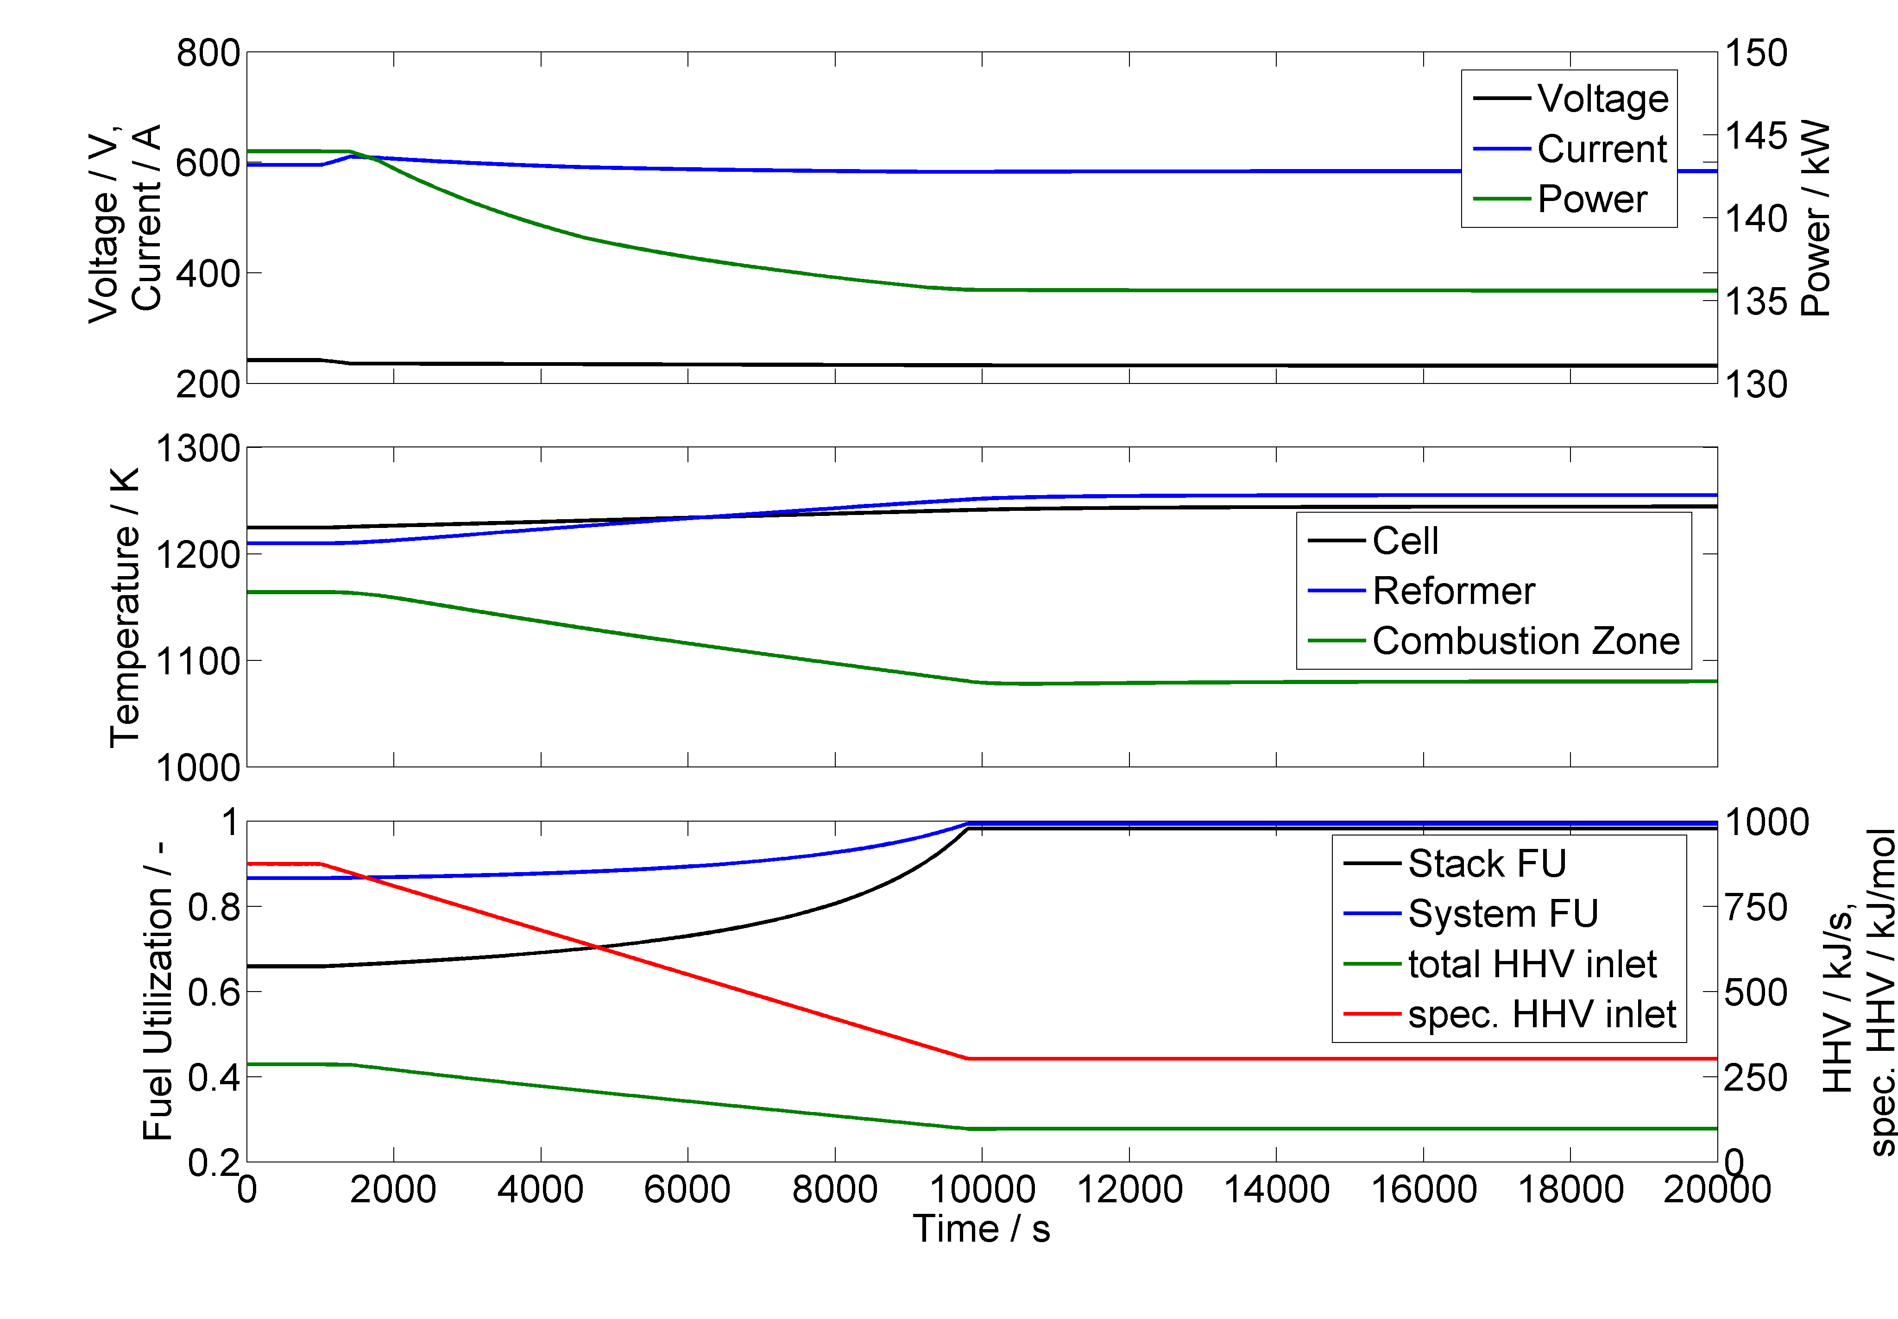
Figure 1: System behavior during uncontrolled transition from methane to hydrogen as fuel.

Enhancing system control
Analyzing the system behavior in Figure 1, there are three possibilities to enhance fuel flow control, combustion zone temperature, power and voltage. Current also changes visibly during the transient but as the total fuel flow is based on current according to Faradays law, alternating the fuel utilization based on the same variable might cause instabilities.
Basing fuel flow control on the combustion zone temperature would reduce fuel utilization until the combustion zone temperature would be constant. This would include raising the fuel flow even if it would not be necessary in terms of delivered power.
The result is shown in Figure 2. It can be seen, that now the system is able to supply the power required. This is due to the reduced fuel utilization set point (not shown). Keep in mind that the system control still does not know about the fuel composition change, but only tries to stabilize combustion zone temperature. This results in visibly reduced stack fuel utilization, while the overall system fuel utilization stays constant. This difference between fuel utilization set point and real fuel utilization is due to the fact that fuel composition is accounted for when calculating the fuel utilization shown here.
It can also be seen, that the total energy fed to the system (HHV fuel gas inlet) is actually rising in this scenario, which leads to a reduced system efficiency.

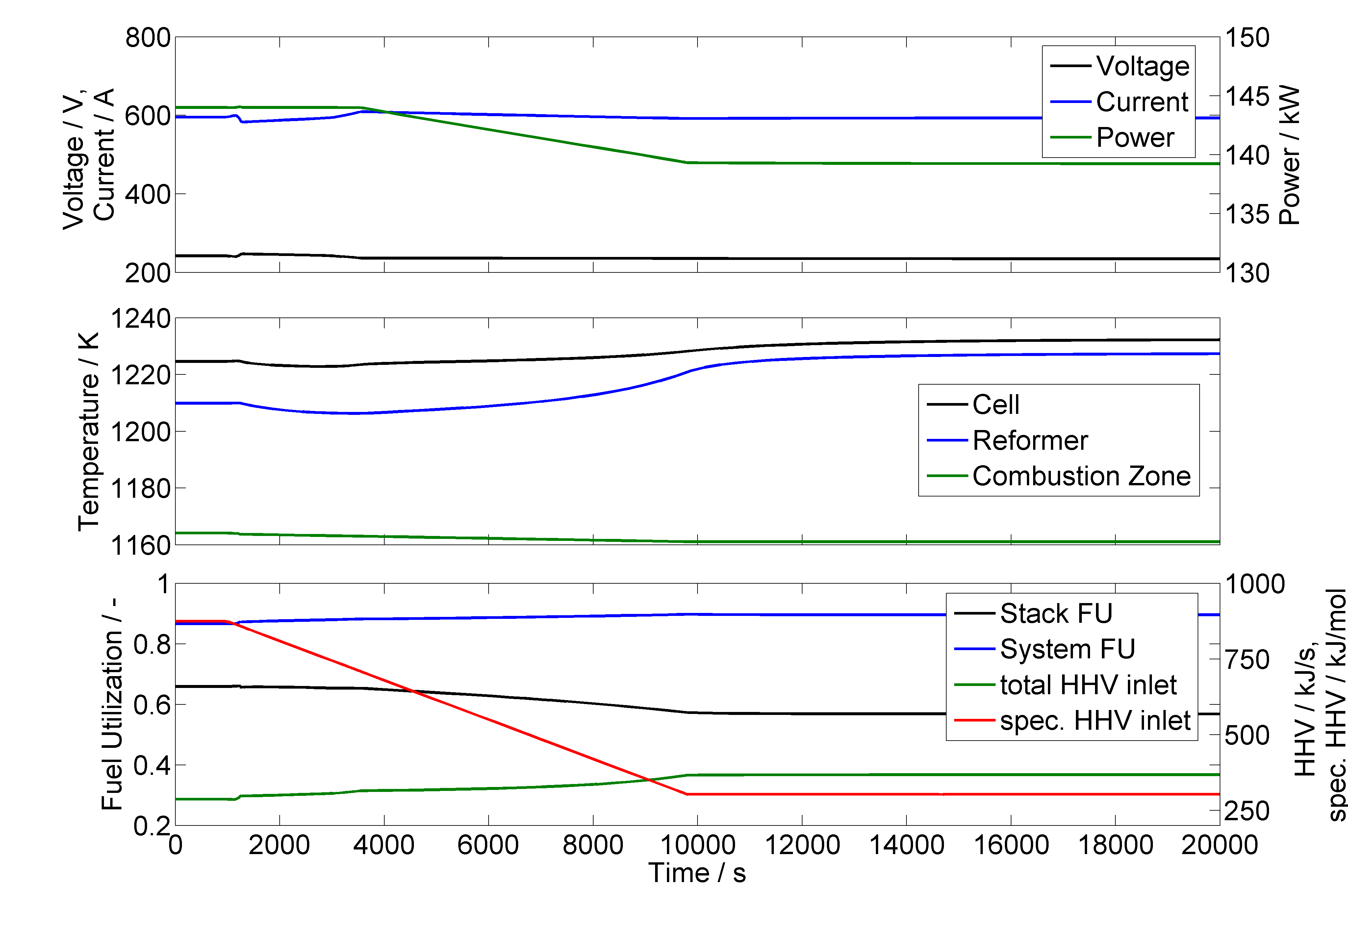
Figure 2: System behavior for transition from methane to hydrogen as fuel with fuel flow control enhanced by FU manipulation based on combustion zone temperature.

If fuel flow control is enhanced using delivered system power as an additional input parameter voltage and current are not changing dramatically during the transition. This is shown in Figure 3. One can also see that with this control the cell temperature stays pretty stable and is only raised, when combustion zone temperature is rising above 1250 K. It can further be seen, that stack and system fuel utilization is reduced. It can also be seen, that the energy fed to the system is increased close to 350 kJ/s from 220 kJ/s before.
In the final control approach presented here fuel utilization is manipulated based on the system voltage. These results are shown in Figure 4. It can clearly be seen, that neither voltage nor current change during the transition. Again there is a visible decrease in system and stack fuel utilization as well as a clear rise in supplied energy.

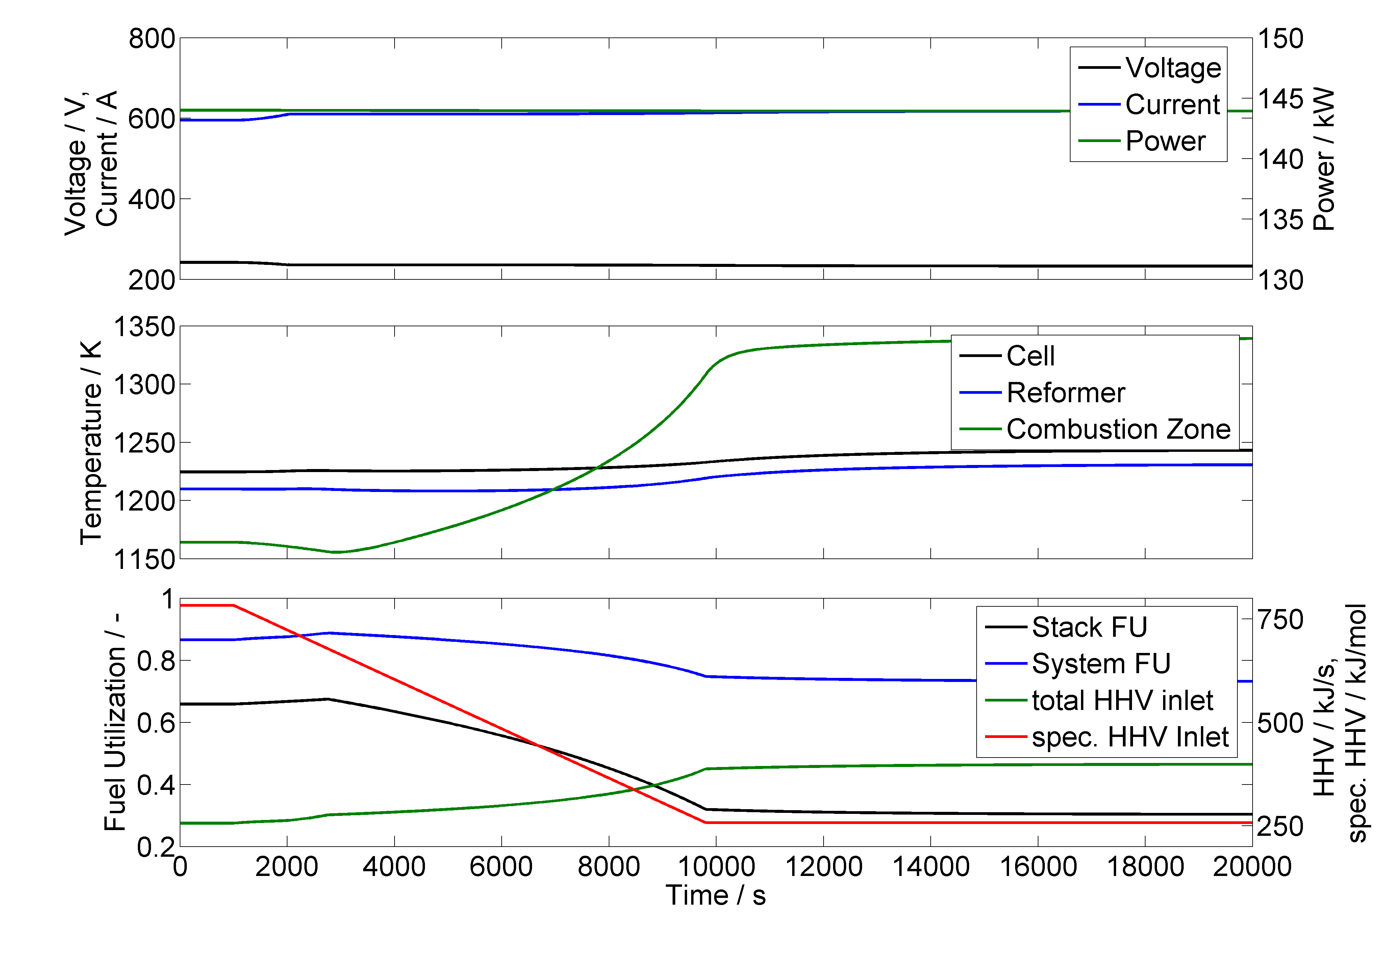
Figure 3: System behavior for transition from methane to hydrogen as fuel with fuel flow control enhanced by FU manipulation based on systems delivered power.

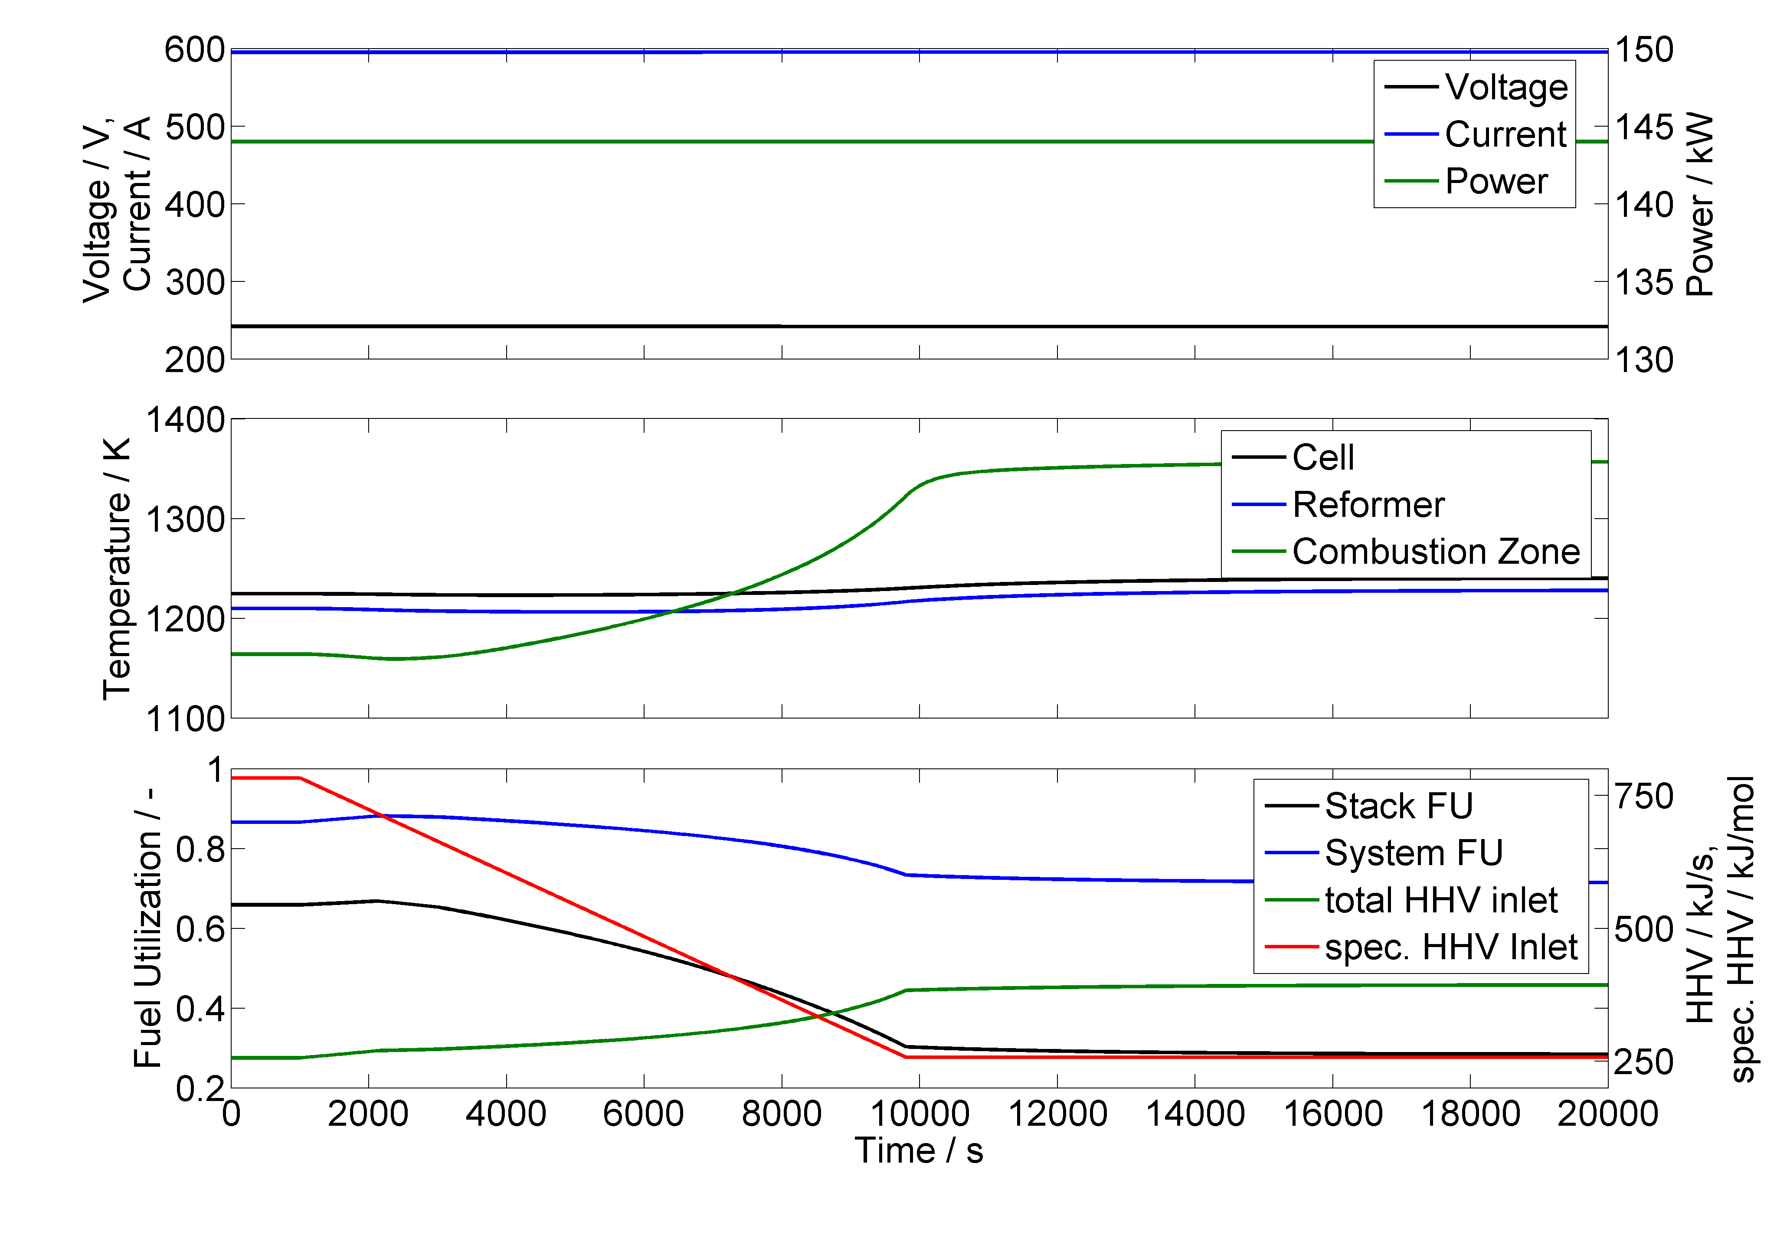
Figure 4: System behavior for transition from methane to hydrogen as fuel with fuel flow control enhanced by FU manipulation based on system voltage.

Hydrogen influence on system efficiency
With hydrogen as a fuel an influence on system efficiency can be expected. In the cases presented in this paper the system was designed to run on natural gas, including a reformer to supply hydrogen to the system. This reformer also acts as a heat sink, using some of the waste heat to reform natural gas. If this system is operated with hydrogen as a fuel system efficiency will decrease. As can be seen in Figure 5, system efficiency can be kept highest if the system is operated with a control utilizing online information on fuel quality.
Analyzing this graph please keep in mind that this does not resample stationary system efficiency. The hooks in the first couple of percents hydrogen mixed to the fuel gas are due to numeric instabilities and would not appear in a stationary operation at the respective point of the transient.

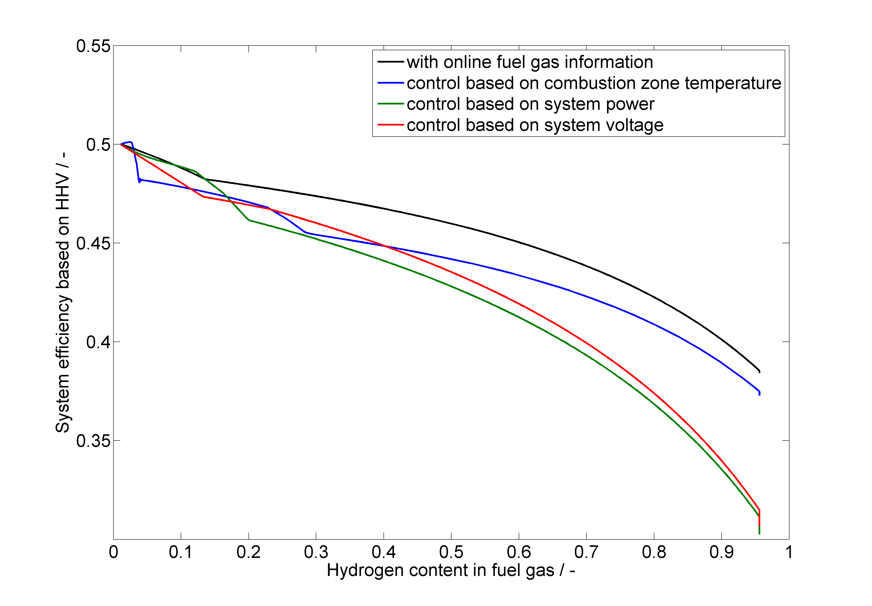
Figure 5: System efficiency over hydrogen contents for various control approaches.

Conclusion
In conclusion it can be seen that an SOFC system can be operated on hydrogen rich fuels, but this will have major impact on efficiency and operating temperatures. Proper controls can keep power output stable and the system in non-starvation conditions. However, if a system was planned to be operated on hydrogen containing fuel mixtures, this should be taken into account when planning system architecture.

References
[1] F. Leucht, W. G. Bessler, J. Kallo, K. A. Friedrich and H. Müller-Steinhagen, Fuel Cell System Modelling for SOFC/GT Hybrid Power Plants, Part I: Modelling and simulation framework, Journal of Power Sources, 196, (2011) 1205-1215.

[2] S. Bajohr, M. Götz, F. Graf and F. Ortloff, Speicherung von regenerativ erzeugter elektrischer Energie in der Erdgasinfrastruktur, 2011

[3] F. Leucht, S. Seidler, M. Henke, J. Kallo, W. G. Bessler, U. Maier and K. A. Friedrich, Solid Oxide Fuel Cells: From Pressurized Cell Tests to System Dynamic Assessment, ICEPAG2011-4406, in ICEPAG 2011, (2011),

