A Robust Management Platform for Multi-Sensor Location Data Interpretation
Christian MANNWEILER¹, Ronald RAULEFS², Joerg SCHNEIDER¹, Benoît DENIS³, Andreas KLEIN¹, Bernard UGUEN⁴, Mohamed Laaraiedh⁴, Hans SCHOTTEN¹
¹University of Kaiserslautern, Wireless Communications and Navigation Group,
Paul-Ehrlich-Strasse – Building 11, Kaiserslautern, 67663, Germany
Email: {mannweiler,schneider,aklein,schotten}@eit.uni-kl.de
²German Aerospace Center (DLR) Oberpfaffenhofen,
Email: ronald.raulefs@dlr.de
³CEA-Leti Minatec, Digital Communications Laboratory,
Email: benoit.denis@cea.fr
⁴Université de Rennes, Groupe Communications Propagation Radar,
Email: {bernard.uguen, mohamed.laaraiedh}@univ-rennes1.fr
Abstract: Location information is the key context information for multiple applications and services and it is also used to effectively filter additional context information. An increasing demand for always available context information is imposed by multiple new applications like cooperative and cognitive communications and cooperative positioning applications. In order to reliably provide location information, multi-sensor environments comprising of different location sensors, location and situation dependent data fusion rules and even other context sensors will be used. A broad market introduction hence requires a support for multi-sensor and multi-vendor plug and play location sensors. A heterogeneous location information management system, as presented in this paper, disposing of open interfaces, allows any kind of location sensor to be exploited and, at the same time, to rate and rank sensors according to their performance in order to provide data about the reliability of the provided location information.
Keywords: Localization, Context Filter, Horizontal Location Management System

Introduction
The mobile Internet has witnessed a surging demand of terminal applications for permanently available context information. Despite the availability of heterogeneous types of context data, location has by far remained the most important context for the majority of applications. Moreover, location is also used as a filter for other kinds of context data.
In order to provide location information in both outdoor and indoor environments that suffices the levels of availability and preciseness required by the quickly growing range of applications, not only multi-sensor environments comprising different types of location sensors with both high and low data quality, but also location- and situation-dependent data fusion rules and even other context sensors are exploited. At the same time, requirements on the quality and availability of location information will grow. Due to the heterogeneity both in the technological as well as in the application domain, a broad market introduction requires a system that supports multiple detection technologies as well as multi-vendor systems in a “plug&play” manner. The solution proposed in this paper is a horizontal location information management domain with open interfaces that allows any kind of location sensors to be exploited and, at the same time, to rate and rank the sensors according to their performance. EU FP7 projects C-CAST and WHERE developed major contributions in these areas (cf. Table 1).
Table 1: Goals of the Projects C-CAST and WHERE
C-CAST | WHERE
Environment-mediated group multicast and context casting | Physical layer technologies and procedures which take into account positioning information
Interoperation of current cellular & wireless infrastructures with an evolved form of context casting and smart spaces | Optimization of communications infrastructure based on positioning information of base stations and possibly RAN nodes
Cellular multicast and environment-actuated context casting | Multipath and non-LoS mitigation algorithms for signal correlation based positioning techniques
Exploit possibilities for greater interaction between mobile device and environment | Hybrid fingerprinting techniques using both measurement-based and ray-tracing based databases
The remainder of the paper is organized as follows. Section 2 outlines the varying requirements for location information imposed by different application domains. Section 3 gives an overview over state-of-the-art positioning technologies and remaining challenges. The proposed location information management system and associated challenges in the implementation of such a system are described in Sections 4 and 5, respectively. The paper concludes with a summary and an outlook in Section 6.

Application-Specific Quality Requirements for Location Information
In 1996, the US Federal Communications Commission (FCC) mandated the network-based localization requirements for mobile phone emergency calls to the network operators: 67% of the calls should have an accuracy lower than 100m and 95% of the calls an accuracy lower than 300m. For mobile based location of the mobile terminal the accuracy is stricter: 67% of the calls should have an accuracy lower than 50m and 95% of the calls have an accuracy lower than 150m. The applied method in GSM and UMTS is U(plink)-TDOA that requires synchronized base stations. On the one hand, for indoor environments, such accuracy is highly questionable but, on the other hand, it was the launch to consider location information for numerous “location based services”. Today, numerous FP7 projects, like E3, Socrates, Aragorn, etc., investigate self-X (X= healing, configuration, etc.) solutions for future wireless radios and expect that positioning information is mandatory. Today, positioning systems based on GSM and Wi-Fi from, e.g., Ekahau (1-3m in known Wi-Fi networks) or Skyhook Wireless (onboard of the iPhone, about 20-50m in urban areas) already enable thousands of applications for the mobile user by providing location information [1] – augmented reality is one of the newest developments that demands high accuracies in urban areas.
The capability to collect as many information sources as possible (either centralized or distributed [2]) from mobile nodes of a network is the enabler for serving future demands (besides higher accuracies, also lower latency and power consumption, etc.). Either network or mobile oriented positioning will enable ubiquitous positioning – including indoor environments (where any support of GPS or Galileo is missing).

Provisioning Location Information: State of the Art and Challenges
This section describes techniques providing the overall location information based on hybrid data fusion [3] (HDF). HDF combines multiple sources to draw a deduction that is more efficient, accurate, and robust compared to the inference from a single source. Figure 1 shows how positioning information is derived by combining various sources with different methods.
For reliable positioning information, it is necessary to exploit as much positioning information as possible. Typical measurements to compute the position of MSs include time(-difference) of arrival (T(d)OA), angle of arrival (AOA), received signal strength (RSS), fingerprinting, etc. Different systems may provide these position based measurements, e.g., cellular mobile radio communications systems, short range communication systems, or global navigation satellite systems (GNSSs). Potentially, each additional available measurement can improve the accuracy, availability, and reliability of the overall position solution.
At each time step of the algorithm, the positioning system provides a new estimate of the MS position. This position is obtained by an underlying tracking process using techniques like (Extended) Kalman Filter ((E)KF) or Particle Filter (PF). The filtering requires a measurement vector using a set of anchor nodes (ANs) in order to provide both the estimated position (EP) and the associated position accuracy (PA). As long as the required PA is fulfilled in the current context, the filtering keeps the same set of anchor nodes which may be either cellular base stations (BS), wireless access points (AP), or user MSs. In a mobility context, the measurement dataset may become insufficient to obtain the required PA. This can be due either to AN death or to the degradation of the AN geometrical distribution. The MS has to perform new measurements in order to reach the requested PA. This choice is made carefully to reduce the network with useless measurements.
The latitude the MS can achieve will depend on the context and circumstances which will affect the number of available neighbour AN. Three cases can be distinguished:
- A low number of neighbours are available
The only solution is to rely on the infrastructure and possibly on fingerprinting techniques if available based on prior information stored in a database of the association between a given position in the radio scene, (possibly in a geographical database) and a set of position dependent observables gathered by the MS.
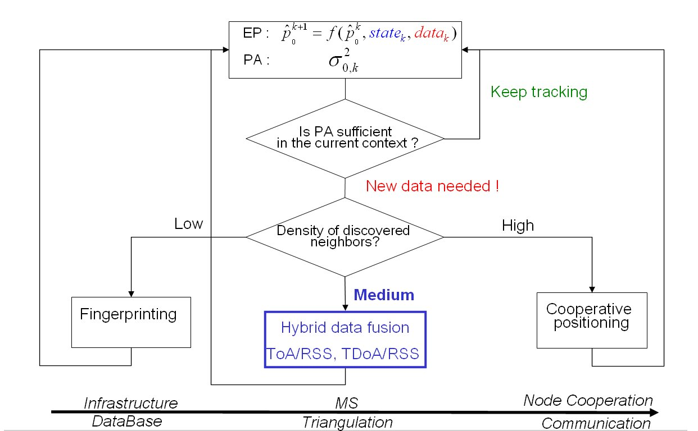
Figure 1: Hybrid data fusion using numerous sources to evaluate positioning information
- A medium number of neighbours are available
The number of neighbour ANs is assumed to be sufficient to provide the required PA through triangulation and/or trilateration. The aim is to complement the radiolocation metrics available by default (e.g. cellular RSS measurements) at minimal number of additional observables (e.g. shorter TOA measurements). Therefore, the system will try to reduce the number of ranging procedures for economical reasons. So, how to choose the best set of neighbours which can achieve the requested PA with the lowest resources?
- A high number of neighbours are available
The high density of available nodes allows through the knowledge of short-range connectivity (e.g. the relative distances measured between them through TOA estimation) to access directly precise position information (either based on centralized or distributed approaches). However, it may happen that some isolated nodes suffer from such a lack of connectivity that the “graph” they belong to cannot be uniquely localizable and/or does not verify basic Euclidean consistency rules. The new question that appears complementary to the previous: May additional radio means and measurements (e.g. cellular RSS on top of short-range TOA) make the situation uniquely localizable again?
Figure 2 shows an indoor scenario supported by outdoor base stations. This scenario assumes high accuracy positioning in indoor environment using different observables coming from both immobile BS with known positions and wireless ANs. These ANs may be either immobile APs or MSs (red) able to compute their positions. This scenario could consider hybrid fusion with, e.g., two kinds of measurements which have contrary ranging accuracies: Vague cellular RSS (LTE) and accurate UWB TOA or TDOA. To answer if there is a benefit we need a) to decide if this kind of hybrid fusion presents an interest, b) to identify specific situations where this association is of use and c) to obtain optimal algorithms. Figure 3 shows the CDF of 2D positioning errors of successfully localized MSs. The gain obtained by HDF in terms of both the positioning accuracy and location success rate (i.e. the average ratio of localizable nodes per network realization) shows benefits compared to strategies not considering fusing measurements (as represented by the blue and black curves, with respectively UWB only or LTE only).
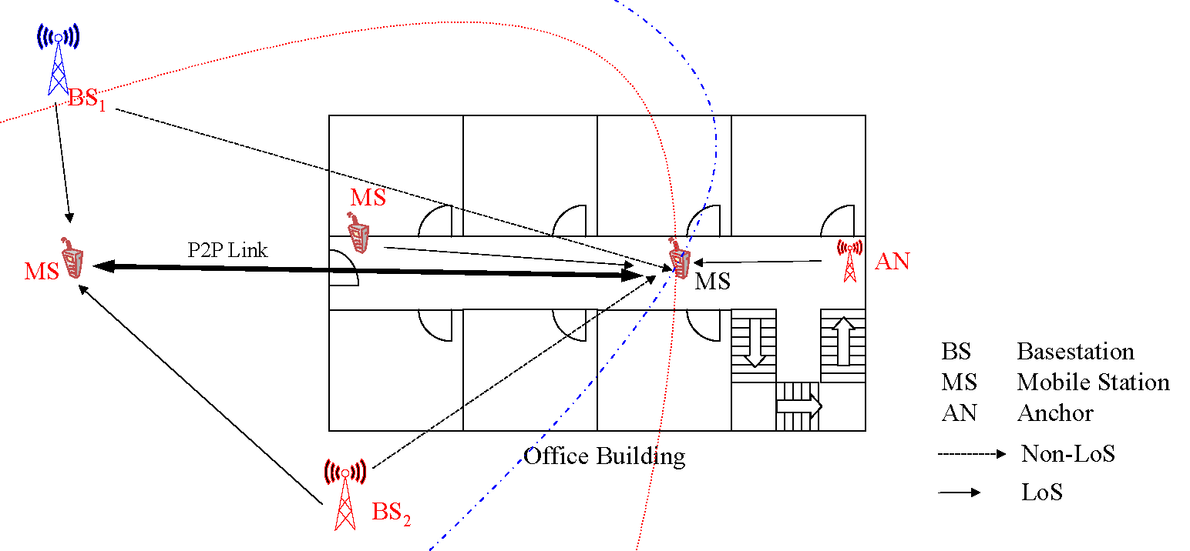
Figure 2: Outdoor and indoor radio sensors cooperating with each other (red ones have exact positioning knowledge)
This is the case even with selective HDF strategies, which do not concern all nodes but just those identified as “unrealizable”. Selective HDF means that the nodes requiring HDF are selected according either to the “sub-graph partial realizability” criterion (magenta curve) or “at least 3 neighbours” criterion (green curve). Exhaustive HDF means the fusion with 3 cellular RSSIs is systematically applied to all the nodes, without any prior selection (red curve). This selective HDF suffers from very slight degradations in comparison with the exhaustive fusion. The performance degradation is more noticeable in the “large-errors” area (beyond RMSE_{min}=10m). The gain is significant independent of the targeted position accuracy and the selective fusion criterion (i.e. rigidity-based or connectivity-based). The benefits from HDF are visible in the “small errors” area with low RMSE, for instance with 70% of the nodes suffering from errors better than 1m, versus 64% when using only UWB means. The gain is still evident in the “large errors” area. For instance, 20% of the nodes suffer from positioning errors beyond 10m - but perform still better than in a pure LTE-enabled system. When relying only on UWB, errors beyond 10m reach about 30%, with errors that can be even worse than that of a pure LTE-enabled positioning system. However, even if the position accuracy available with HDF is always better than that of independent UWB or LTE systems (and hence completely valuable in wide areas, in the lack of local references, like outdoor environments), it might be more questionable for the initially claimed indoor environment (here a 30m×30m area). At first sight, achieving a precision worse than the size of the explored geographic area could look irrelevant. For these nodes suffering from errors worse than 10m even after HDF, it is worth considering alternate or complementary positioning strategies (e.g. coarse connectivity-based positioning algorithms, operating only from the number of hops with respect to anchors) or enhancing the fusion process by adding additional information sources.
Figure 3: Answering where HDF delivers a benefit.
It is worth noting that the continuity of the location service is at least ensured with the proposed HDF, even if the achieved precision can hardly be constant over time depending strongly on local connectivity conditions. Indeed, with regard to the ratio of localizable nodes per trial (i.e. the percentage of nodes that have a well-defined RMSE_{min} after any positioning procedure), the election of the most judicious UWB nodes applying to HDF with cellular means (and hence, with RSSI measurements) plays a critical role here.
Initially, the HDF process should help to deliver locations (even if erroneous) for the nodes which could not be localized through UWB means (e.g. because of not enough neighbours). The erroneous locations could be eliminated by adding more information sources as outlined in Section 4. Therefore, the classical claim in favour of using HDF is that fusion improves the continuity of service, as well as the coverage.

Horizontal Context Management System with Open Interfaces
The preceding sections have demonstrated the technological as well as functional heterogeneity of providers of location information in the wireless communications and navigation domains. In order to make the available infrastructure and according data available to any entity of a given system, there is a need to interpose a functional layer that standardizes location information, associated metadata as well as the description and performance evaluation of providing entities [4]. C-CAST has developed such a platform that suffices the following requirements [5]:
- Enhance and leverage location data
Applying filtering mechanisms as well as evaluation metrics are used for improving (multi-dimensional) quality of location data. Moreover, data can be semantically augmented by means of aggregation, fusion, inference, and prediction.
- Exchange data within and between distinct context management domains
The system has to implement mechanisms for discovery, distribution, and exposure of location context and providers. Moreover, the system has to dispose of open and uniform (inter- and intra-domain) interfaces to enable “plug&play” functionality and overcome vertically integrated solutions. Finally, extendible entity management procedures, e.g. for entity resolution, have to be implemented.
- Ensure E2E data security
The system needs to dispose of mechanisms that guarantee an unobtrusive policy enforcement and prevent a violation of privacy, security and trust.
The C-CAST context management system (Figure 4) consists of three basic entities: Context Providers, Context Consumers, and Context Brokers. Context Brokers (CB) are the key components of the architecture. They work as a handler of both context data and, more importantly, context providing entities [6].

Figure 4: C-CAST Context Management System
In the specific case of location information, data obtained from multiple sources may suffer from information inconsistency, inaccuracy, imprecision, incompleteness, and other data quality problems [7]. The designed system therefore incorporates automated location data cleaning algorithms that improve the quality of the raw context by detecting and removing or correcting unreliable values. Moreover, location data collected from different technological sources (as described in Section 3) is processed in order to represent it in a unified way. “Cleaned” data can be semantically enriched by means of fusion, extraction and reasoning [8]. Context mining algorithms are applied for deriving new context (e.g. movement patterns) from the available raw context data such as sensor values.
Moreover, forecasting of future context leads to significant performance improvements for some classes of services [9]. As an example, simulation results in Figure 5 highlight the gain in terms of performed handovers in a multi-RAT (radio access technology) environment with a few thousands terminals if methods for terminal location prediction are included in handover decisions [10].
However, in the long term, additional issues need to be addressed in order to fully achieve the objectives defined above. Figure 6 outlines the required functional components for a universal location data management system. Most importantly, it constitutes of a horizontal layer between location data consumption and provisioning domains, thus enabling a vertical disintegration of formerly integrated solutions. Open and standardized interfaces towards both domains assure compatibility between independently designed providers and consumers.
Figure 5: Intra- and Inter-RAT Handovers Depending on Context Prediction Inclusion
An initial (Java-based) implementation of the system has been tested in interaction with a simulation framework for heterogeneous RAT environment (cf. results in Figure 5). The system has been able to reliably cope with up to 4000 mobile terminals and a diversity of location data sources including WiFi, cellular, RFID, GPS, and HDF-based positioning technology, some of which have been simulated and others as actual implementation.
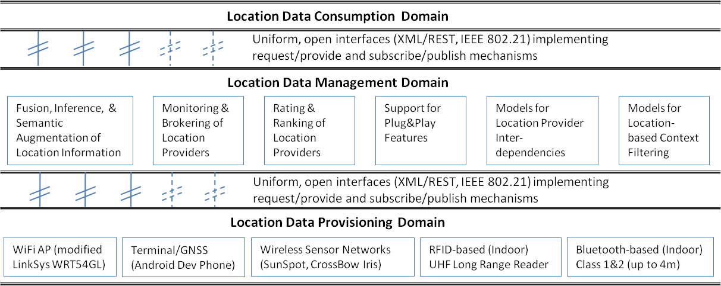
Figure 6: Hardware, Functionality & Embedment of Location Data Management System

Resulting Challenges for Implementation
Available implementations of context management frameworks (CMF) generally serve specific use cases for context utilisation and typically have extension constraints. For example, many frameworks only support selected localization techniques and very coarse-grained levels of abstraction. The architecture proposed in Section 4, which supports a high distribution level, even across heterogeneous management domains, has to scale for carrier-grade deployment and hence imposes several challenges. Context federation, the proposed concept for a distributed approach, copes with issues such as the discovery of context providers, their description, their rankings etc. that need to be done between the federated entities. Further challenges in this domain are depicted in Table 2.
The development of a decentralized solution that supports mobile and local context management addresses the requirements in terms of scalability and extendibility of the system. Complexity is particularly increased by the heterogeneity of location information sources. These can be distinguished through the following characteristics: multi-vendor hardware, different localization technologies, diverging quality in terms of availability, granularity, accuracy, and topicality, as well as different levels of abstraction.

Conclusions and Outlook
We have outlined the heterogeneity of sources for location context as well as its broad range of application domains in wireless communications. Combining different radio technologies, HDF has proven to be very beneficial for location estimation with some constraints in indoor environments. Moreover, the design of a system for scalable and extensible location information management has been presented. Key innovations are the possibility to cope with any sensing technology and vendor by providing uniform interfaces and data representation formats as well as the capability of applying rules for complex combining of varying location data sources.
Future work includes the development of a framework for a multi-dimensional abstraction function that can map location data between different abstraction levels.
Table 2: Implementation Challenges for a Location Information Management System
Challenges in System Compatibility | Challenges in System Intelligence
“Plug&Play” functionality for simple integration of new components into the existing system | Filtering, aggregation, and basic reasoning algorithms inside the location provider entity
Open and standardized interfaces: different localization technologies can be hidden inside the provisioning entity; location data is made available to any entity adhering to the common interfaces | Definition of a logical hierarchy of context sources to aggregate/filter information at the right abstraction level
Location provider indexing and brokering service | Inference algorithms capable of complex combining of different location data as well as semantic augmentation
Monitoring services that allow to evaluate the availability, reliability, integrity, and security of individual as well as clustered context sources | Supervised and unsupervised cooperation mechanisms between different sources of location data sources
Location provider ranking functionality that is able to select available providers according to different parameters | Exploitation of location information for filtering of other context data in order to extract relevant data from large amounts of data
Acknowledgment
This work has been supported by the projects ICT-217033 WHERE, ICT- 216462 C-CAST (both partly funded by the European Union), and G-Lab (funded by the German Ministry for Education and Research).

References
- Study of Location based Applications on Mobile Terminals: http://www.skyhookwireless.com/locationapps/
- H. Wymeersch, J. Lien, and M. Z. Win: Cooperative localization in wireless networks. Proc. IEEE, vol. 97, no. 2, pp. 427–450, Feb. 2009
- EU FP7 ICT WHERE, Deliverable D2.1: Performance assessment of hybrid data fusion and tracking algorithms, http://www.kn-s.dlr.de/where//documents/Deliverable21.pdf
- J. Schneider et al.: Erfassung von Umgebungskontext und Kontextmanagement. Proceedings of the 14th ”ITG-Fachtagung” Mobile Communications”, Osnabrück, 2009
- EU FP7 ICT C-CAST, Deliverable D10: Requirements and Global Reference Architecture. http://www.ict-ccast.eu/files/C-CAST_D10.pdf
- EU FP7 ICT C-CAST, Deliverable D12: Specification of Context Casting Service Enablers, Context Management & Context Brokering. http://www.ict-ccast.eu/files/C-CAST_D12.pdf
- A. Klein et al.: Exploiting User and Network Context for Intelligent Radio Network Access. Proceedings IEEE ICUMT 09, St. Petersburg, 2009
- J. Himberg et al.: Time series segmentation for context recognition in mobile devices. IEEE Conference on Data Mining, Los Alamitos, CA, 2001, pp. 203–210
- R. Mayrhofer: An Architecture for Context Prediction. Dissertation, University of Linz, 2004
- C. Mannweiler, et al.: Context-Awareness for Heterogeneous Access Management. In: Advances in Radio Science – Kleinheubacher Berichte 2009

